|  |
| --- |
| HND |
| D:\Myint Myat Kaung\2nd year 1st sem Assignment\Untitled-1 copy.PNG**Unit 39:E-Commerce and Strategy** |
| ***Developing the E-Commerce site for “ALL-4-U” Company .Ltd***  **may Thet HtAr Aung**  Batch –66  2nd year, First Semester  Assignment  **Start Date : 25.2.2022**  **End Date : 18.3.2022** |



Info Myanmar College

**Contents**

Introduction 3

LO1. Examine the strategies employed and the impact of E-Commerce on business organizations . 3

P1: A learner has to discuss the importance of addressing and meeting the customer expectations for employing an E-Commerce. 3

What is E-Commerce? 3

Customer’s expectations for E-Commerce Website 4

Speed and Simpler Purchase path 5

Self-Service Support 5

Credibility and visually appealing 5

Detailed, accurate information on products 5

Product images and testimonials 5

Payment Method 6

Shipping information and post-transaction notifications 6

LO2. Analyze the hardware, software, web-based and database technologies involved in setting up a secure E-Commerce site. 7

P2: A learner needs to discuss the technologies involved in setting up a secure E-Commerce site. 7

What Technologies Are Required For The Development Of An E-Commerce Website? 7

The Process of E-commerce Website Development 7

LO3. Design an E-Commerce strategy based on a given end user requirement or specification. 10

A learner needs to discuss the types of strategies that could be used to drive a successful E- Commerce solution. 10

Importance of Website for Business Success 10

Strategies that would Be successful E-commerce 10

P4. A learner needs to consider and design an attractive web application for an E-Commerce solution based on a specified requirement or strategy. 13

Website Wireframe 13

LO4. Implement an E-Commerce strategy based on a given end user requirement or specification. 21

P5. 21

Admin Site 21

Client Site 29

Reference 44

# Introduction

I had to implement Web E-commerce site for the “All-4-U” Company Limited as a web developer. This company is Limited is one of the successful convenience store company in Yangon, Myanmar. It sells a variety of products, such as snacks, stationaries, cold beverages, hot beverages and daily necessities. “All-4-U” Company Limited recognizes the potential benefits of applying the emerging E-Commerce strategies and solutions for better customer service and business growth. As a web developer, I just assigned to examine the strategies and the impact of E-Commerce on organizations, research technologies and resources related with setting up a successful E- Commerce site and finally, design and implement an E-Commerce strategy that meets business goals and requirements of your organization.

# LO1. Examine the strategies employed and the impact of E-Commerce on business organizations .

## P1: A learner has to discuss the importance of addressing and meeting the customer expectations for employing an E-Commerce.

## What is E-Commerce?

Ecommerce, often known as electronic commerce or online commerce, is the purchasing and selling of goods and services through the internet, as well as the financial and data transfers required to complete these transactions. Ecommerce is frequently used to refer to the online sale of real goods, but it can also refer to any type of economic transaction that is made possible by the internet. While e-business encompasses all aspects of running an online firm, e-commerce focuses on the exchange of goods and services.

The concept of e-commerce has grown around the world since the early 1990s. For business people and owners of large companies who wish to sell or buy their goods and products in any country on the Internet, e-commerce has brought numerous benefits. Sales and customer service activities are aided by e-commerce. There are numerous websites dedicated to e-commerce. There are some essential elements of E-commerce that you should be aware of to answer numerous questions when opting to construct an electronic commerce website, namely:

* E-commerce allows businesses to access the worldwide market via the Internet without having to make significant financial commitments.
* It enables suppliers to be closer to their consumers, resulting in enhanced productivity and company competitiveness.
* It gives you all of the information you need about each product and allows you to compare it to similar products on other websites.
* It saves consumers time and effort by facilitating the purchasing and selling operations through electronic means.
* These new and different sorts of e-commerce provide more efficient pre-and post-sale support.

On the Internet, there are a lot of options for promoting and distributing goods and services. The six primary divisions of e-commerce are as follows:

E-commerce is divided into 6 basic types, namely:

1. Business-to-Business (B2B)
2. Business-to-Consumer (B2C)
3. Consumer-to-Consumer (C2C)
4. Consumer-to-Business (C2B).
5. Business-to-Government (B2G)
6. Consumer-to-Government (C2G)

## Customer’s expectations for E-Commerce Website

Nowadays, Customers are informed, connected, and web & tech-savvy, so simply maintaining a fast and high-performance website for your online webstore isn't enough. In the eCommerce industry, they have a wide range of brand options and products to choose from this. Hundreds of eCommerce websites now exist where users can purchase the things they require. Web businesses must focus on providing a complete customer experience to be successful in today's online economy and to establish loyal customers for their online stores. Because of the vast number of options available in the online marketplace, eCommerce web-stores are competing primarily on customer service thereby building a relationship with the customers. There are a few basic expectations of the consumers from e-commerce online store owners.

### Speed and Simpler Purchase path

Consumers expect instant access and a faster buying procedure when shopping online. They are not used to waiting for long periods of time. As a result, if your online store's website takes too long to load, people feel annoyed and refuse to continue the complicated purchasing path. As a result, clients are more likely to go to a competitor's online business to meet their specific needs.

### Self-Service Support

Self-service is preferred by online clients over email or telephone support. Any e-commerce website's product listing and description should be content-rich, giving all of the information your buyers require. A wide range of detailed information on the products, such as images, shapes, sizes, pricing, discounts, and warranties, should be enough to assist buyers in finding answers to their questions on their own.

### Credibility and visually appealing

Customers want an e-commerce store's internet websites to be visually appealing and trustworthy. They expect their e-commerce websites to protect their personal information, such as credit card information and mailing addresses.

### Detailed, accurate information on products

Customers frequently go online to avoid dealing with sales representatives. On the product page itself, try to provide as much information about the product as possible, including reviews, technical specifications, and USPs. Potential purchasers may abandon their quest for the goods on your website if the content is insufficiently detailed. Always keep the product page updated (especially if the most recent batch of the product is different) since the product must match the description—any inaccuracies will cause buyers to be dissatisfied with their purchase and request a return.

### Product images and testimonials

When it comes to making a purchasing decision, images are one of the most crucial considerations. Customers have more faith in your product when they see high-quality photographs from numerous angles. To make browsing more engaging for your customers, make sure the product photos load quickly and include options like zoom to the photographs. Another important factor when purchasing a product is hearing other customers who've bought it vouching for its quality. Knowing what other people think about a product and what their shopping and product experience has built trust in your brand. Your customers will feel more comfortable purchasing from you when they can see and read authentic, unbiased, third-party ratings and reviews.

### Payment Method

On most e-commerce websites, most of the customers would be using many types of methods credit cards, debit cards, net banking, digital wallets, and mobile payments. So you should connect with that payment system in your organization. When you connect with those payment organizations, they will give you many chances for your customers. So your customers always thought firstly your website when they want to buy something.

### Shipping information and post-transaction notifications

Customers make the last purchase once they're comfortable with the transport details. Adding the perfect product to the cart, only to be instructed at checkout that it will take a month to deliver, is a turn-off. First and foremost, inform the purchaser of correct anticipated shipping date and the shipping cost. If you anticipate the shipping to be late, keep the consumer informed. While free deliveries are the great option, if there are shipping costs, point out them upfront so that clients don't abandon their carts. Also, if there is faster shipping available, consist of that information.

After a consumer has bought something, notify them straight away by using email, message, or text about their purchase. This sets expectations about the communication channel you will use for sending and receiving information. Send out a receipt with all the important points and supply a link for tracking their order. If possible, add a greater advanced feature like e-mail and transaction updates where you can directly message clients in case of any delays or send personal messages. Customers will greatly recognize the proactive gesture.

# LO2. Analyze the hardware, software, web-based and database technologies involved in setting up a secure E-Commerce site.

## P2: A learner needs to discuss the technologies involved in setting up a secure E-Commerce site.

## What Technologies Are Required For The Development Of An E-Commerce Website?

Ecommerce has improved the way individuals buy and sell online over the last several years. People can buy products online quickly and easily without having to go to a physical store. Customers from all over the world can shop at an online store. To combat economic difficulty, online firms are fast creating an ecommerce website by giving higher discounts, flat-rate shipping, loyalty programs, and other incentives. Many popular ecommerce platforms make running discounts and keeping your customers satisfied simple. Finally, while the increase in online sales has created an opportunity for fraud and scams, site builders have stayed ahead of the game by providing top-of-the-line site protection and payment security to maintain the online marketplace as secure as possible. One of the most popular business trends is creating a successful ecommerce site. Setting up an online business (not underestimating it) or developing an e-commerce website may appear to be a monumental undertaking, but as you've probably heard from most of the people out there, it isn't that difficult.

### The Process of E-commerce Website Development

To create an e-commerce store and run a successful online business, you'll need a variety of ecommerce tools and technologies. Your e-business plan must contain both software and hardware technologies.

**Web Server**

An e-commerce website is hosted on a web server. This server houses all of the HTML, JavaScript, PHP, databases, and media files that make up the complete website. The web server can run on either Windows or Linux. Managing a web server is a specialized task. Website creation firms either host the site on their own servers or pay a hosting firm to give space on a secure server.

**Server Software**

When a user uses a web browser to access a website, the web server recognizes that the client is looking for specific information. As a result, it handles the request and sends the appropriate files to the client. The user is subsequently presented with these files by the web browser. Application software, database server software, file server software, and cloud computing software are all examples of server software. Apache and Windows IIS are two prominent web server programs. Server software can be installed on either a real or virtual / cloud server.

**Web Tools**

The front end of an e-commerce website is created using a web authoring tool. Basic HTML text editors (like Notepad++) to more complicated graphic writing tools and CMS (content management system) with built-in frameworks and debugging tools are among them. Dreamweaver generates HTML files as well as CSS (cascading style sheets), which improve the site's visual appeal. Visual Studio.net is another online publishing tool that may be used to create websites with connected databases. Web authoring tools that develop the skin for a user interface are often known as graphic design packages.

**Database System**

An e-commerce website's database is an essential component. The database stores information on the website's items and services, including pricing, descriptions, images, details, and sales. In addition, the database stores customer information such as what they ordered, payment information, delivery information, and contact information. To ensure that all orders are completed correctly and your business works effectively, you must program the website to connect securely to the database. PHP and MySQL are used to communicate between the website and the database management system (database management system).

**Networking**

TCP (transfer control protocol) and IP (internet protocol) establish how computers connect to each other and share information over the internet. HTTPS, HTTP, and FTP are common TCP/IP protocols. Without realizing it, we use these protocols to access the website. FTP (file transfer protocol) is a technology that allows you to download files from your browser. The secure communication between a server and a browser, such as account information or personal information, is ensured by HTTPS (where the "S" stands for security). A secure connection is deemed necessary for an e-commerce website or online business. The protocols connected with trust and security of any e-commerce website are SSL (secure sockets layer) and TLS (transport layer security).

**Browser Compatibility**

A web browser is a piece of software that searches for, receives, and displays material from web servers. Mozilla Firefox, Google Chrome, Internet Explorer, and Safari are all popular online browsers. Before launching a website, web developers and web development agencies test it to check how it looks on various browsers, devices, and screen sizes. Use tools like Google Analytics to figure out what browsers people are using and which one is the most popular when analyzing website traffic.

**Ports**

Ports allow one device to communicate with another using a separate and distinct IP address. A gadget may have several ports. SMTP (Simple Mail Transfer Protocol) is typically used for email. It's used to send data from email servers that are located on the other side of the world. No emails can be sent if that port is blocked. 80 (HTTP), 443 (HTTPS), 21 (FTP), and 22 (FTP) are some more common port numbers (SSH). To increase security, firewalls can often block a port.

**Domain Names**

Domain names are used to identify a corporation or a brand. Successful e-commerce businesses have well-known domain names. If you run a small business, it is important to choose a domain name that corresponds to your company name. This would assist in achieving a high search engine ranking. If a company becomes popular online, it is critical to safeguard the brand by registering various domain names such as.com,.net,.uk,.org, and.co. This assures that no one may imitate your business strategy and steal your profits. Here's a quick rundown to help you get things in order.

1. Front End: HTML, CSS, JavaScript, Ajax, JQuery
2. Server-Side Scripting: PHP, ASP
3. CMS: WordPress + Woo commerce, Magento, OpenCart, PrestaShop
4. Database: MySQL, MSSQL

## LO3. Design an E-Commerce strategy based on a given end user requirement or specification.

## A learner needs to discuss the types of strategies that could be used to drive a successful E- Commerce solution.

## Importance of Website for Business Success

The majority of consumers are searching the internet for information that will assist them in making better shopping selections. According to the E-Commerce Foundation, 88 per cent of shoppers will conduct product research before making a purchase, whether online or in person. The necessity of a website for today's organizations is highlighted by this purchase behavior trend. You must have a good website if you want your business to be successful in today's industry. Your company's website serves as the foundation for all of your digital marketing activities. The value of a website in terms of marketing extends to all aspects of your digital marketing plan. Every sort of communication, piece of content, or commercial you post online will direct the consumer back to your website, which serves as the backbone of your online presence. As a result, it's critical that your website gives customers a clear picture of your business and the items or services you provide.

## Strategies that would Be successful E-commerce

With an increasing number of people shopping online each year, there's plenty of space for e-commerce companies of all sizes. However, it is more crucial than ever for e-commerce companies to understand their brand, advertise themselves aggressively, outperform their competition, and keep their customers happy. Those following strategies will help you on your way to e-commerce success.

1. Use Professional Product Image
2. Optimize for Mobile Devices
3. Write an FAQ page
4. Create Social Proof
5. Showcase Products on Landing Pages
6. Make Checkout Easy
7. Enable Store Items

**Use Professional Product Image**

In the viewpoint of clients, crisp, detailed photos make your online store more trustworthy (link is external). Online buyers can view how the product looks in real life thanks to professional product photos. Customers will notice that you care about your product and how it is presented if you use high-quality photographs. If you need assistance with image production, look for expert photographers and graphic designers. Although it may appear costly, hiring professionals allows you to present your products in a more enticing manner.

**Optimize for Mobile Devices**

While mobile audiences are on the rise, make sure your designer understands how to optimize a site for mobile and tablet use. Nearly three-quarters of customers use their phones to compare costs, and 61% of those who visit websites that aren't mobile-friendly quit them (link is external). For example, the website Interior Secrets(link is external) adjusts to the size of any device.

**Write an FAQ page**

An FAQ page responds to the most frequently asked queries by your consumers. According to LivePerson's Connecting Consumers research, up to 83 percent of online shoppers require assistance to make a purchase. Your support team will be relieved, and your customers will feel more confident in purchasing from your store, thanks to a FAQ page.

**Create Social Proof**

In this situation, social proof refers to alerting visitors about the behavior of other users on the website rather than on social media. These features are intended to assist customers in discovering what's hot and browsing popular things. Some websites, for example, prefer to display what users are purchasing in real time. When someone completes a transaction, this function displays tiny pop-ups in real-time, allowing visitors to explore new products. The feature also generates a bustling atmosphere in the online store, giving merchants more trust.

**Showcase Products on Landing Pages**

Consider the landing pages on your website to be a welcome mat at the front door. The pages should entice visitors by displaying a sample of what they might expect to discover on your website. Use a rotating banner to highlight your best-selling products. It's an older approach of attracting website users' attention and assisting them in discovering things they might like to buy. When possible, include videos on landing pages. According to e-consultancy, 58 percent of online customers believe that businesses who generate (link is external) video are more trustworthy.

**Make Checkout Easy**

According to a UPS-commissioned study, online customers believe that a simple checkout experience is critical. Over four-fifths (83 percent) think that ease of checkout is one of their top priorities(link is external). Allow people to buy your stuff without initially creating an account with you. Make sure your online store, like Interior Secrets, has a straightforward, one-page checkout process with the bare minimum of information (link is external). The following information can be found on the checkout page:

* Shipping and billing addresses
* Credit card information
* Shipping speed and cost
* Order review
* Coupon code entry
* Delivery instructions
* All information is thematically grouped in boxes to make checkout as intuitive as possible.

**Enable Store Items**

A consumer who has abandoned a purchase can return later to complete it if your site's shopping cart stores items or allows a Wishlist. Basket storage refers to the use of cookies to save information so that clients do not have to re-fill their cart each time they visit your site. You can target the 56 percent of shoppers who save things for subsequent purchase by creating your site in this way (link is external).

## P4. A learner needs to consider and design an attractive web application for an E-Commerce solution based on a specified requirement or strategy.

## Website Wireframe

A website wireframe is a visual representation of a web page's content, layout, and behavior. It frequently lacks in terms of styling, color, and visuals. A website wireframe can also display the relationship between pages, allowing you to travel through a set of mockups with clickable components, similar to a blueprint for a house that shows the plan for plumbing and electricity but not the interior design. A wireframe is a design that uses simple boxes, lines, and other shapes to generate an outline of a web page's functional sections without wasting time on a detailed, polished design. It's frequently the initial step in the website development and design process. A wireframe is a visual representation of a design concept that may be shared with a team, clients, or management. So I will expand my ecommerce website design as a wireframe.

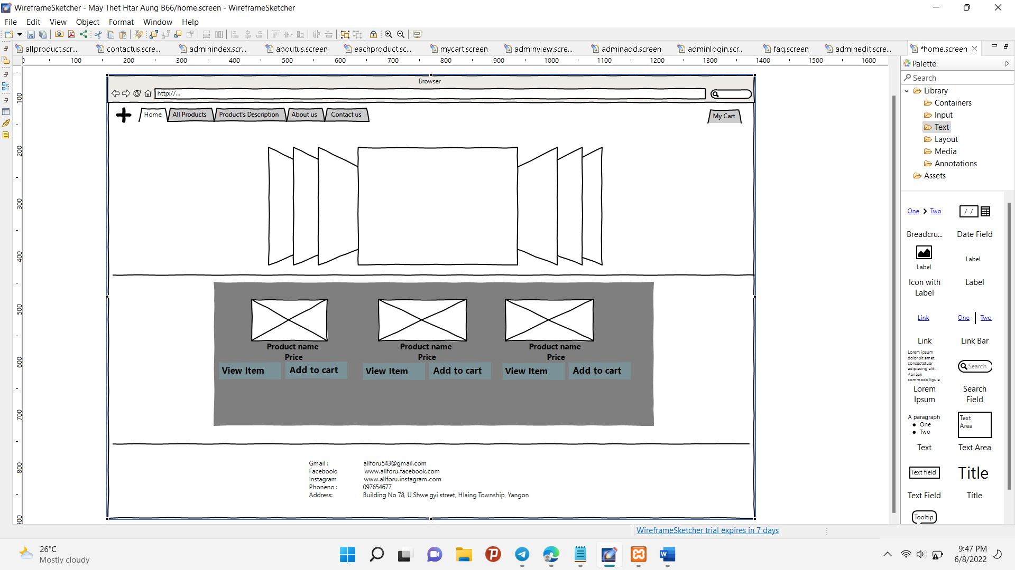

Fig(3.1) Home Page for the Client Site

This page is the main point of the website. In the header section, I added the tabs for the pages. Furthermore, I added the carousel slide. And then in the main section, I showed the images, product names and prices of the popular items. Moreover, I added the view item button and add to cart button. When you click the view item button, you will see the detail of the item and then click the add to cart button, the item enters your shopping cart. In addition, in the footer section, I added the simple form of the company’s address.

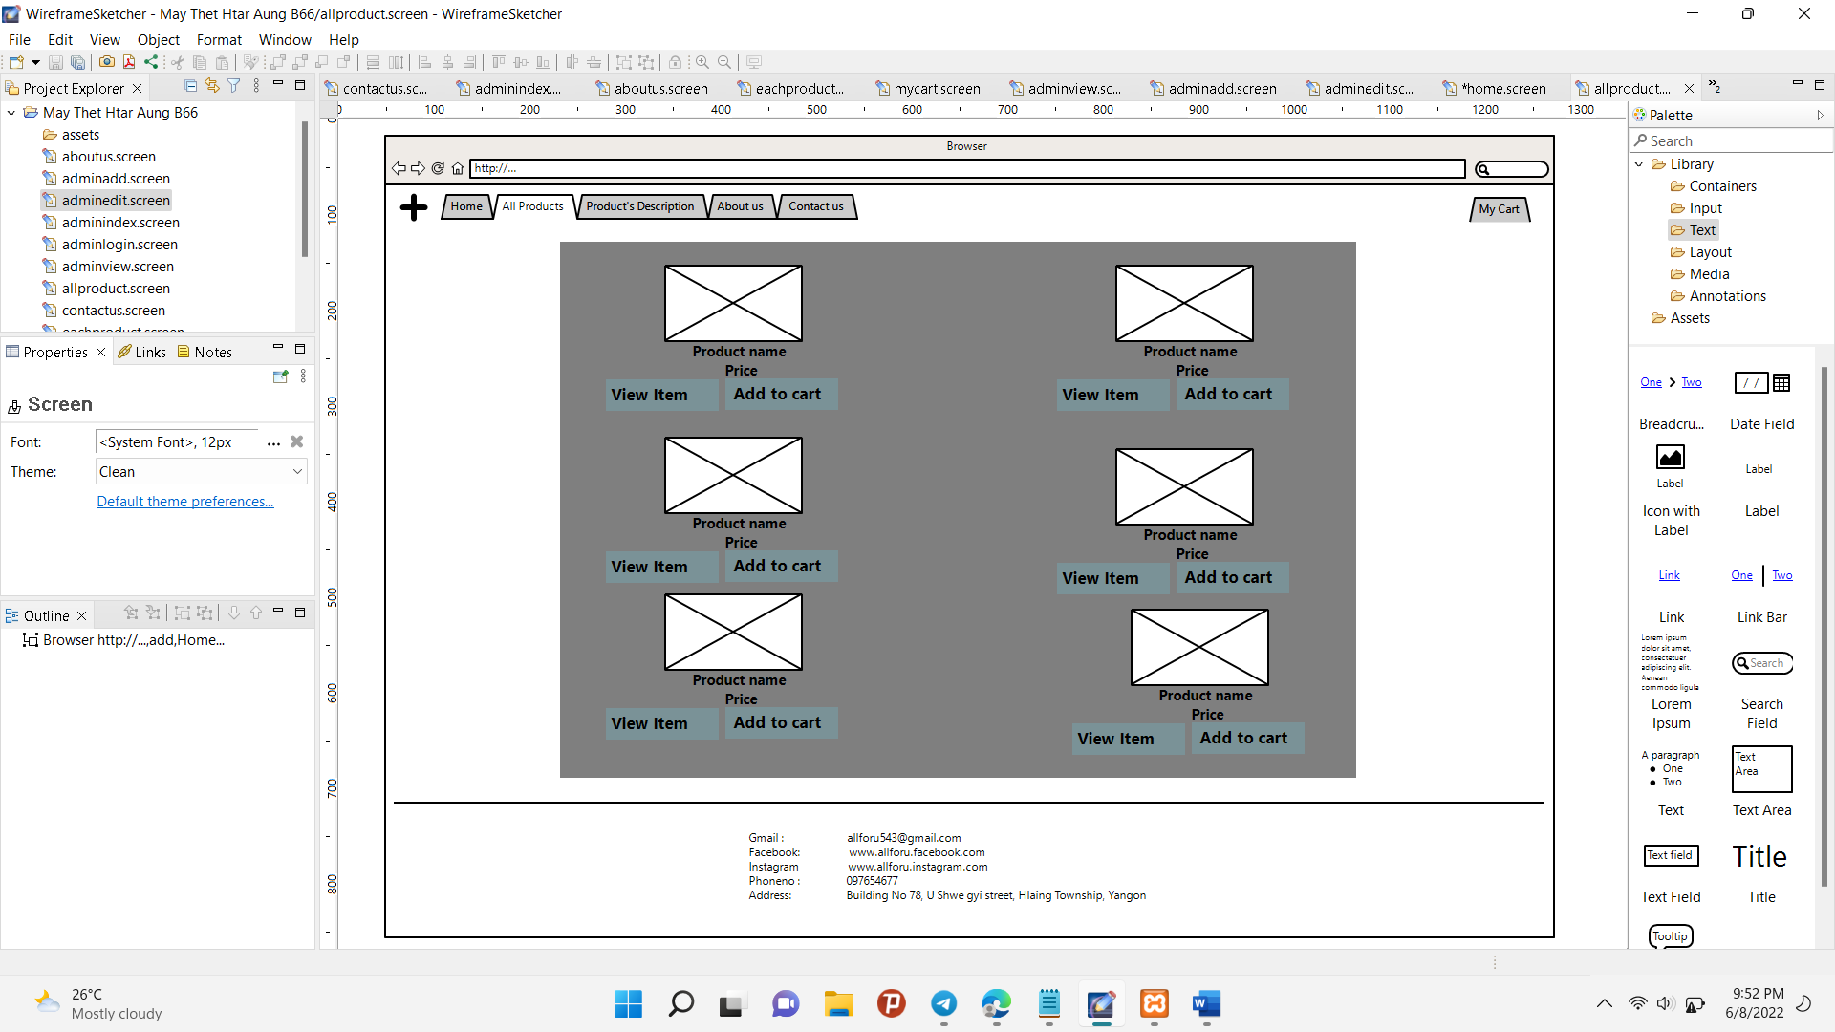

Fig(3.2) All Products Page for the Client Site

All Product Page’s header section and footer section are the same as the home page. In the main section, I showed all items and also did as on the home page.

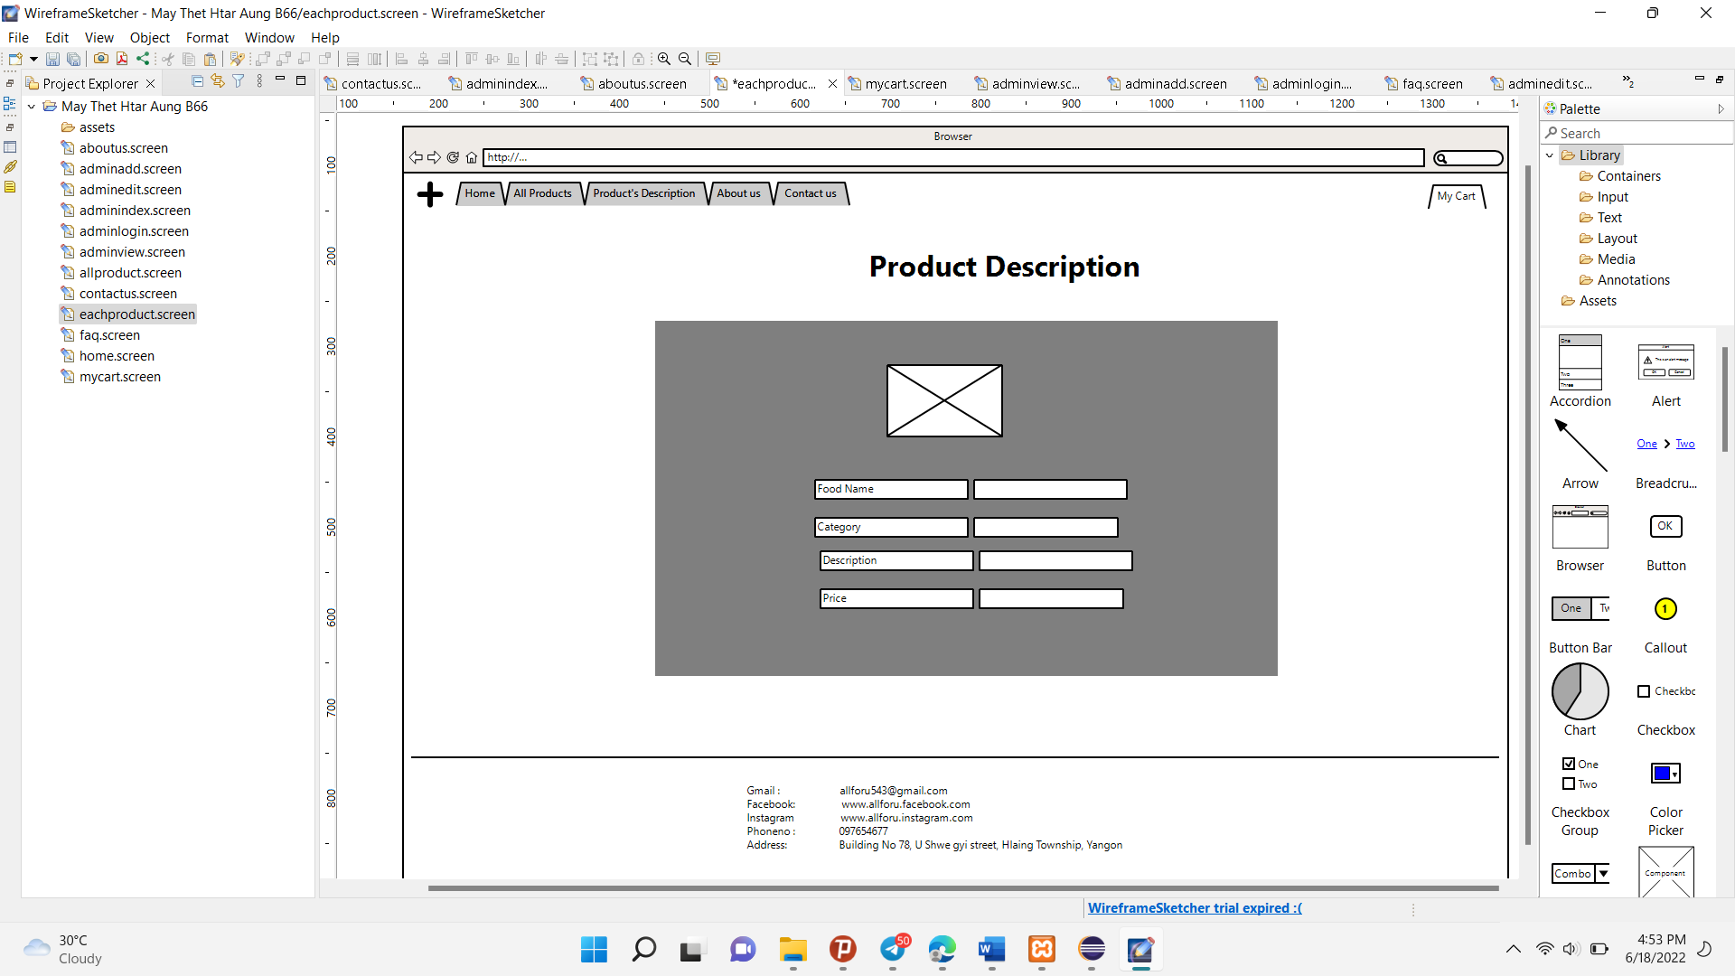

Fig(3.3) View Item Page for the Client Site

The page will arrive when client clicked the view item button on Home page and All product. In this page show the detailed about of the item that client the item.

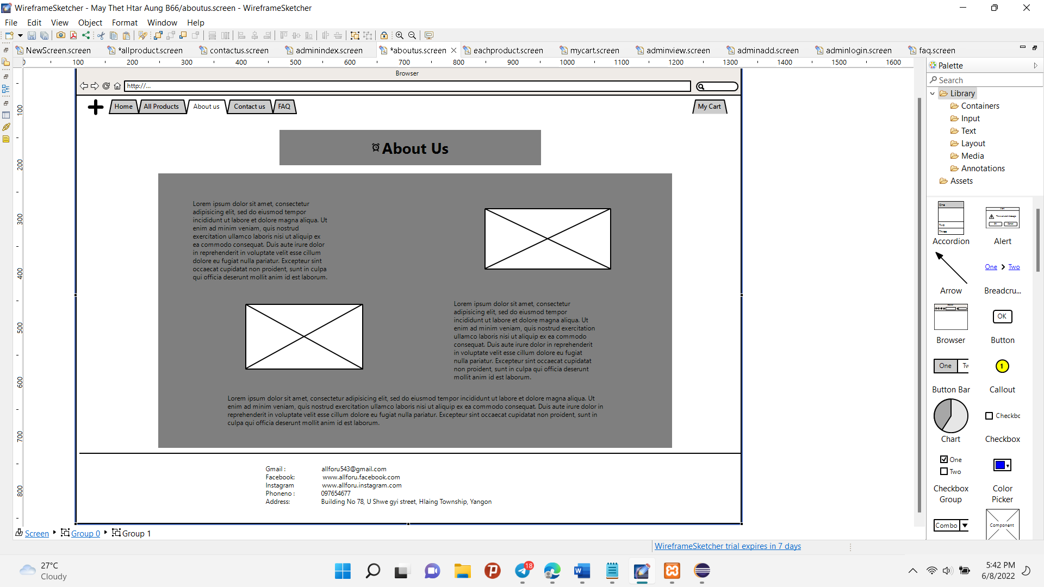

Fig(3.4) About Us Page for the Client Site

About Us page showed the detailed about of the company and some of the company’s images. When you read the page, you will know all about of the company.

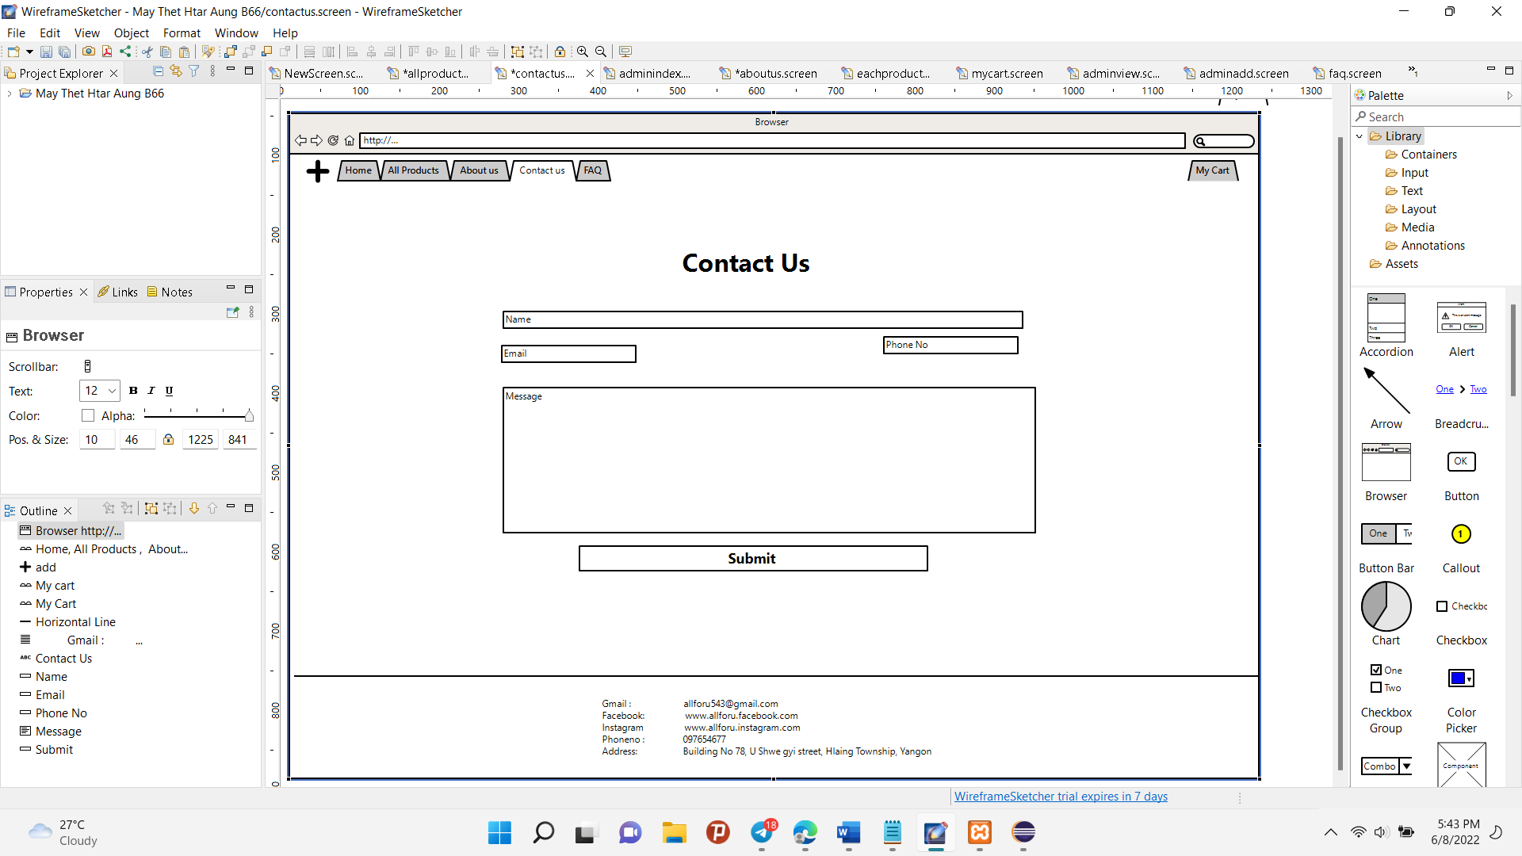

Fig(3.5) Contact Us Page for the Client Site

Contact Us page is aimed to connect with client. If they want to give us some feedbacks, they can fill this form. So, we can repair our requirements of the website.

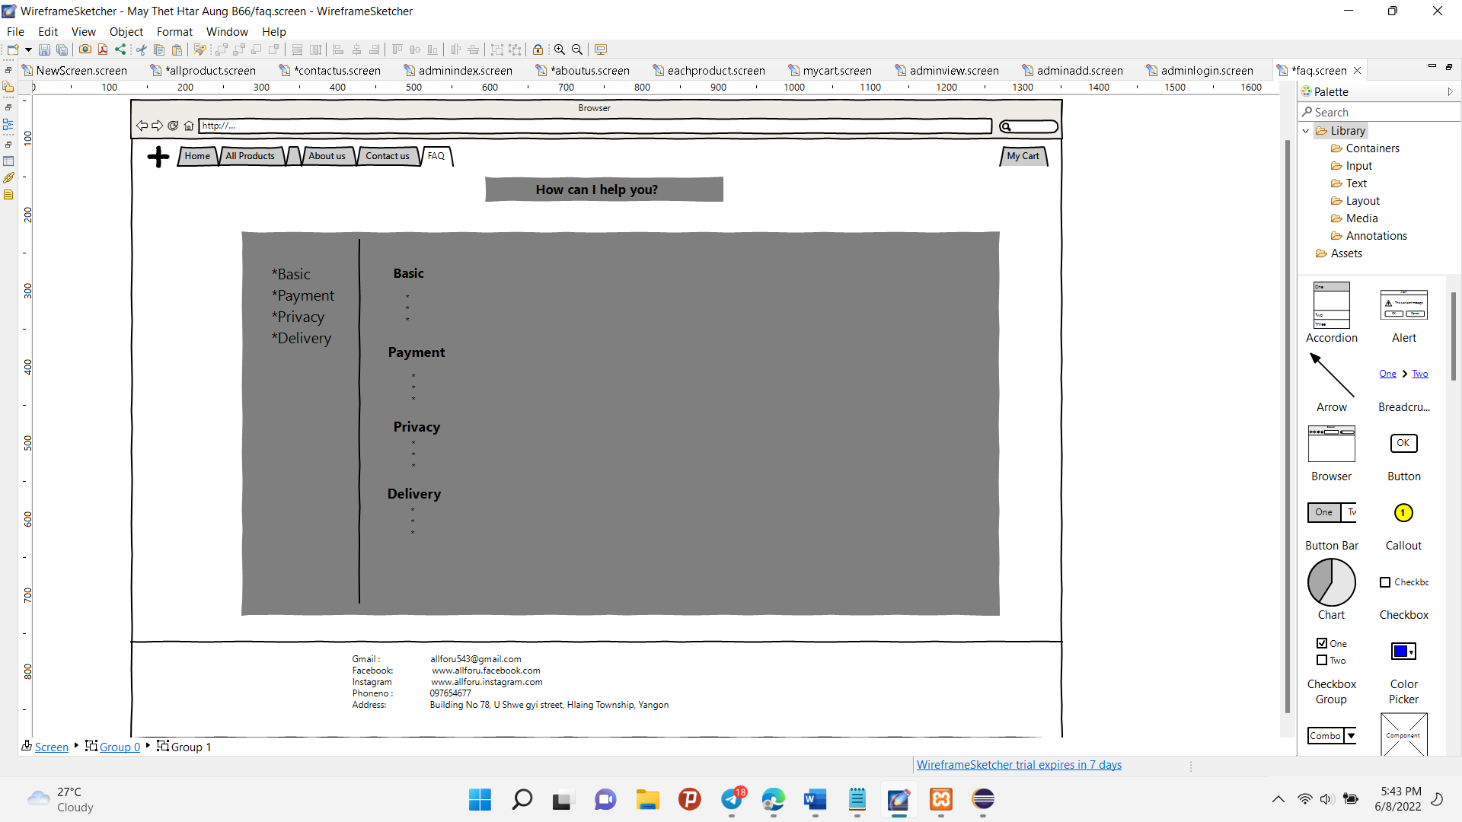

Fig(3.6) FAQ Page for the Client Site

A FAQ page, or Frequently Asked Inquiries page, is a section of an ecommerce store where critical information about a business is given to answer buyers' questions and concerns. So, I divided four section for FAQ page. One each section has 2 or 3 questions.

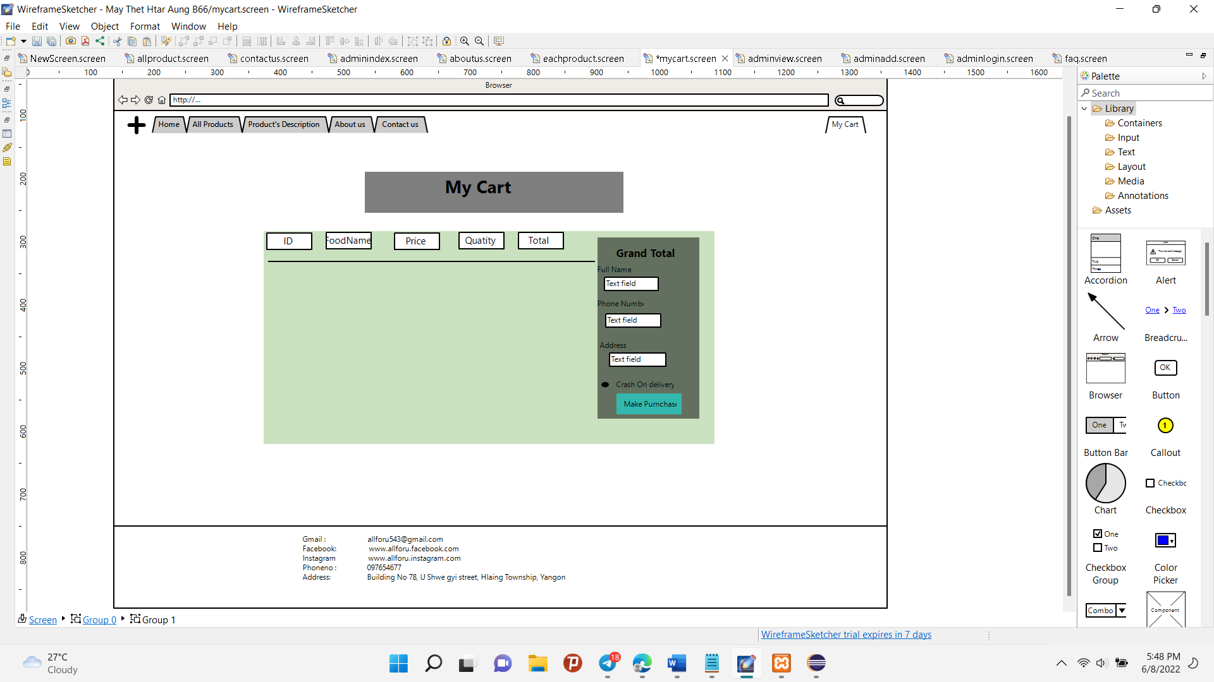

Fig(3.7) My Cart Page for the Client Site

When you click the add to cart button of the item from the Home page and all product page, these items will enter on this page. And then you can change the quantity of what you want to. Moreover, that will show the total price of the items. Furthermore, you can buy all these items if you fill out the form.

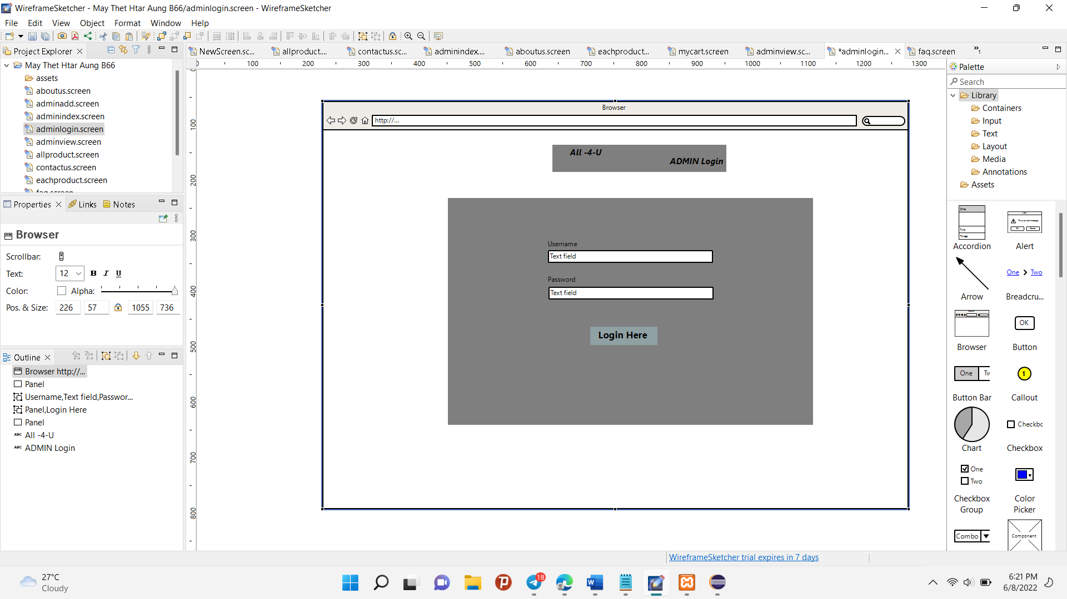

Fig(3.8) Login Page for the Admin site

This Login page is to enter the admin site. If you write the correct username and password then click the Login Here Button, and you will enter the admin page.

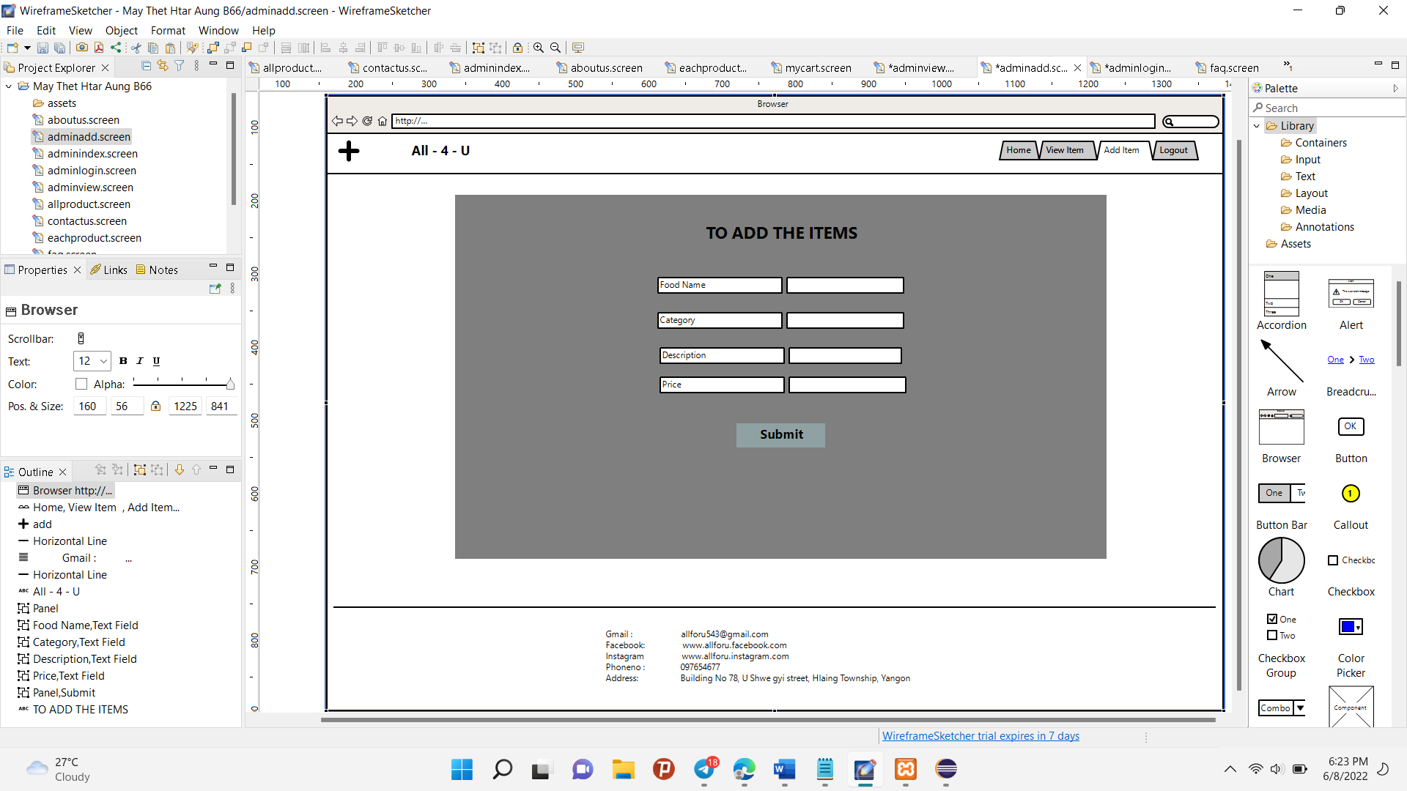

Fig(3.9) Add Item Page for the Admin site

The admin site page is also the Client site page. The header section is Tabs for the other pages. In the main section, the admin will upload the item if they want to and then click the submit button. The item will arrive in the related database. The footer section also showed the address of the company.

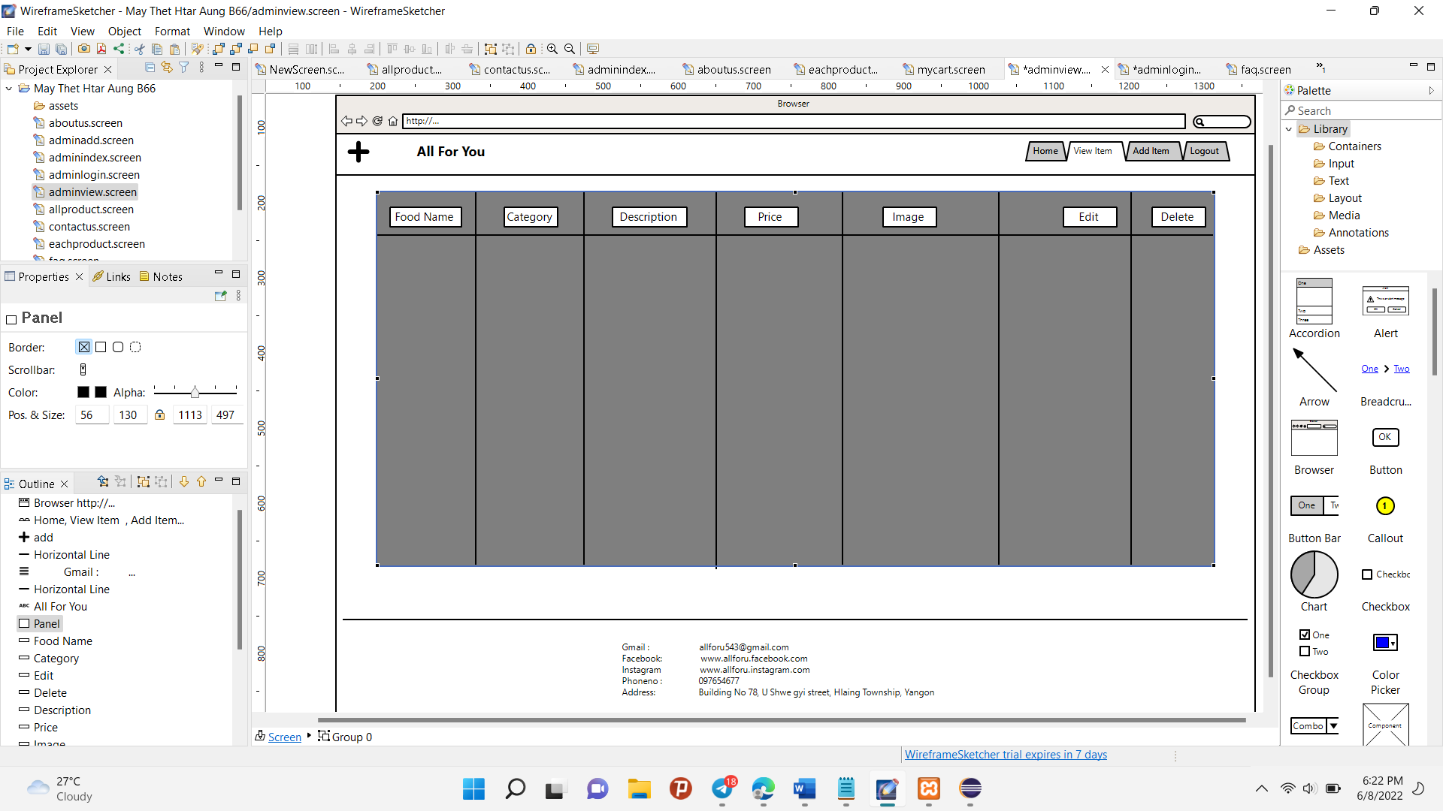

Fig(3.10) View Page for the Admin site

The view page showed the detail about of added the items . And then you can edit and delete these items.

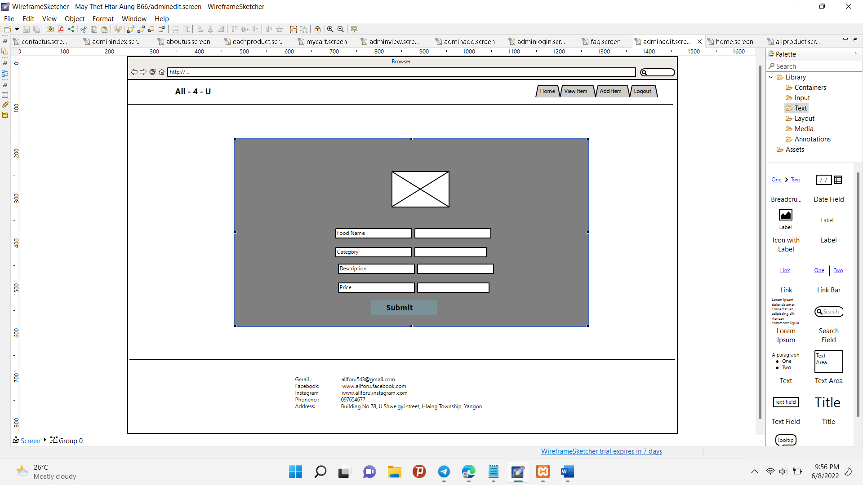

Fig(3.11) Edit Item Page for the Admin site

On the view page, when you click the Edit Link of the item, you will enter the Edit Item page. And then you can change the items.

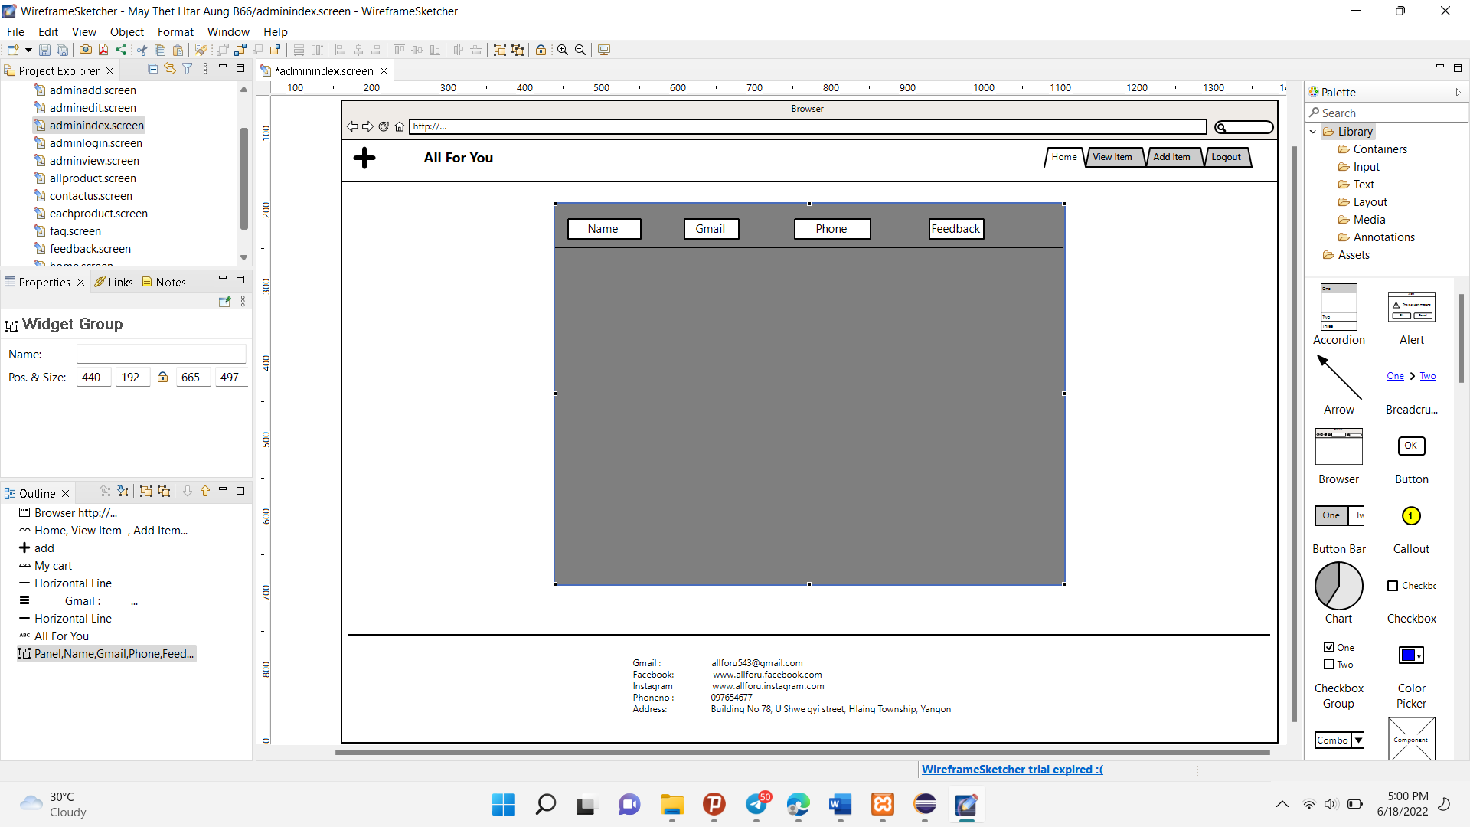

Fig(3.12) Feedback Page for the Admin site

The page is connected with the contact us page of the client. When Client fill the data in the form, that all data will arrive in this Page.

# LO4. Implement an E-Commerce strategy based on a given end user requirement or specification.

P5.A learner needs to consider an E-Commerce solution based on a specified requirement or

strategy. In addition, it is necessary to apply hypertext mark-up and scripting languages as

appropriate: HTML for web pages, CSS for presentation styles, JavaScript for client-side

script, PHP for server-side script and database technology to handle transactions for sales

processes. A learner needs to implement the E-Commerce website with the proper design

with the appropriate structures, web application security and control authentication levels

(administrator and user level). From the administrator side, it can be applied the insert,

update, delete, search and retrieve operations. From the user side, it can be searched

according to the desired electronic product by the brand, the type of the category, the ranges

of prices and so on. A user can also make the shopping process via clicking the add to cart

button and it can be also checked and updated the list of products from the basket. Moreover,

the learner needs to identify the errors that might occur during the implementation of the

given web application and use the appropriate techniques to handle them. A learner also

needs to develop the related reports and user documentation with related screenshots.

## Admin Site

For this ALL 4 U convenience store, I had to develop the admin site and client site. In this admin site, we had to add the items, edit the items, view all the items and delete the items. So, I will develop all these functions on the admin site. And then we had to know the customer feedback on this admin site. So, I’ll create this website for all these functions and related pages.

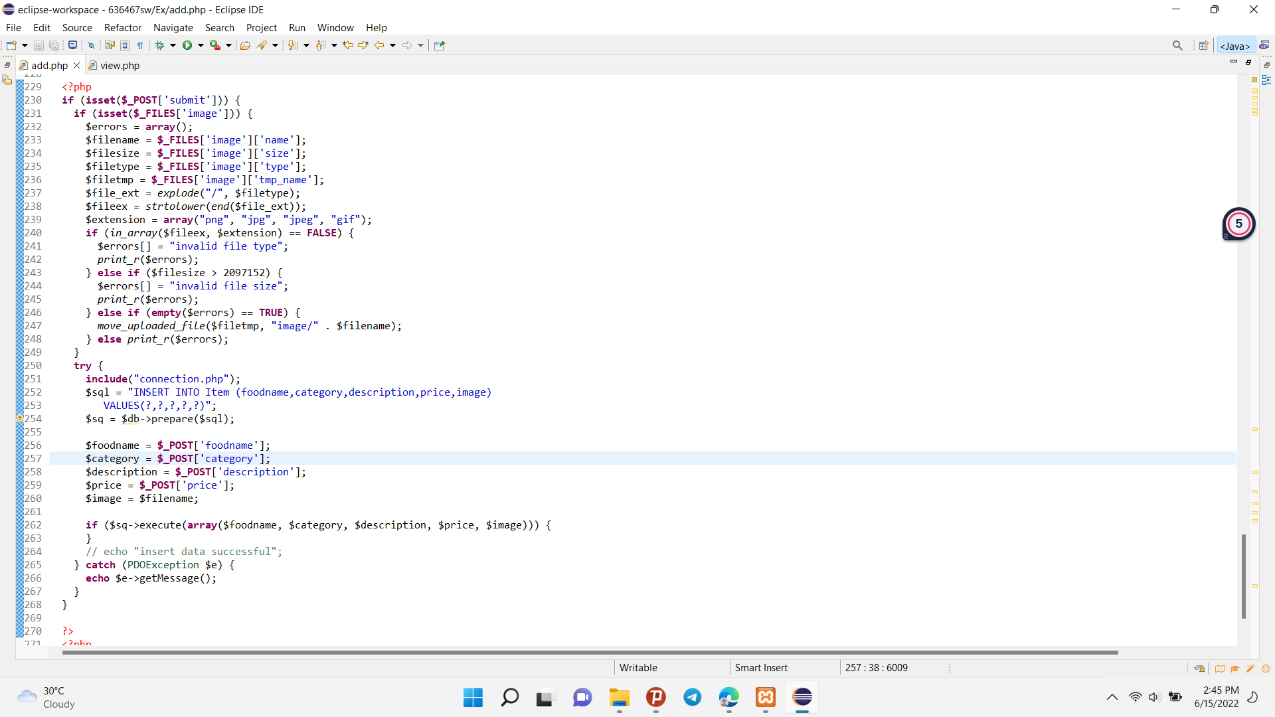

Fig (4.1) PHP code of the Add Item Page

This PHP code is to add the item in the database. Firstly, the html code is showing to fill the requirement of data of the item. And then in this code, you fill the data and click the submit item. If you click the submit button, you will fill the equal type of data so the data will arrive in the database. If the data is not equal or something wrong, the program show the error where it is.

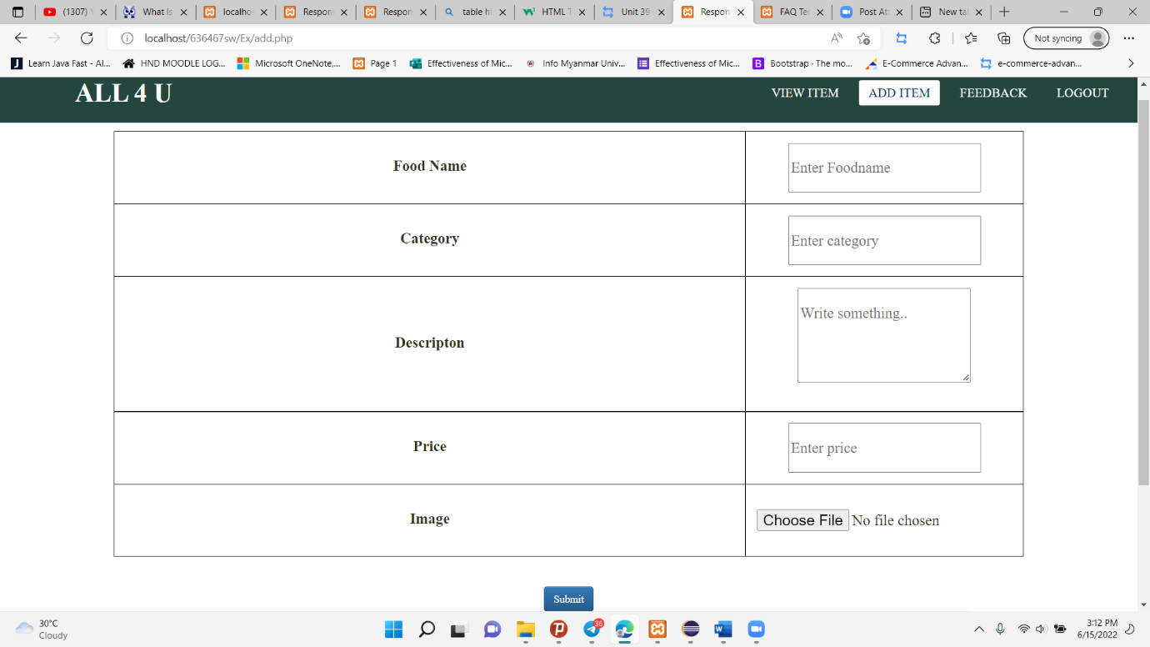

Fig (4.2)Add Item Page

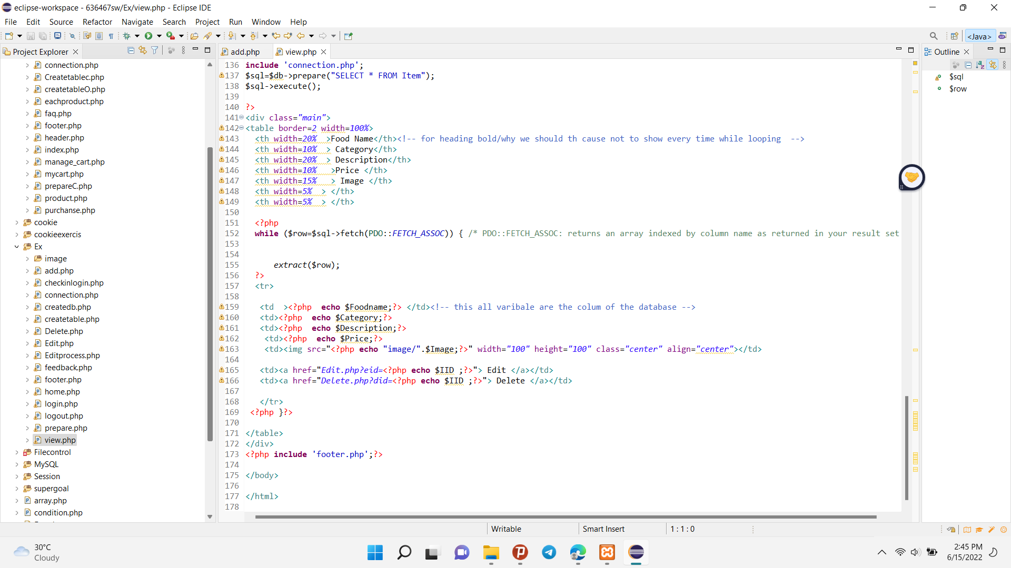

Fig (4.3) PHP code of the View Item Page

This code is to show the data from the item database. Select the data from the item database and then call the variable and show the data. In this code have two patterns . That are edit and delete pattern.

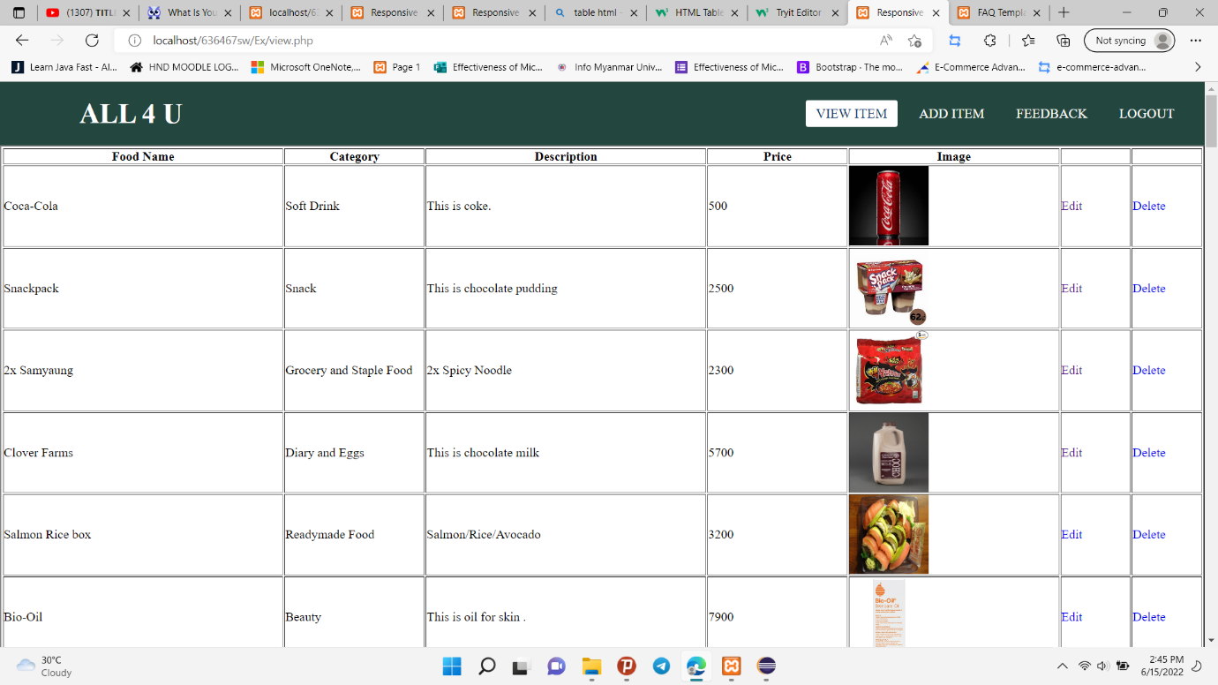

Fig (4.4) View Item Page

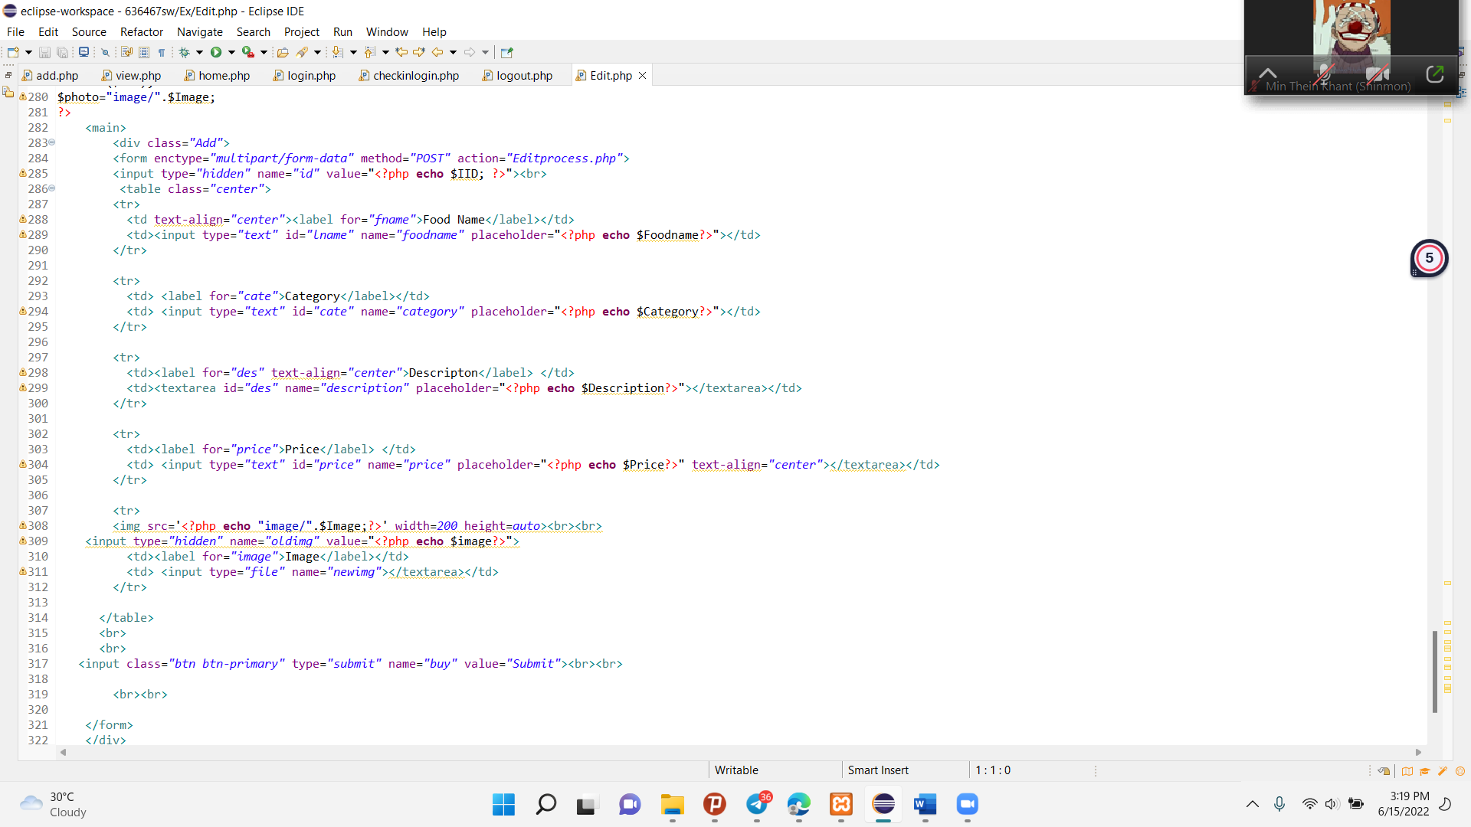

Fig (4.4) PHP code of the Edit Item Page

When you click “Edit” in the view item page, that code will perform. The upper code is to show the original data in the page.

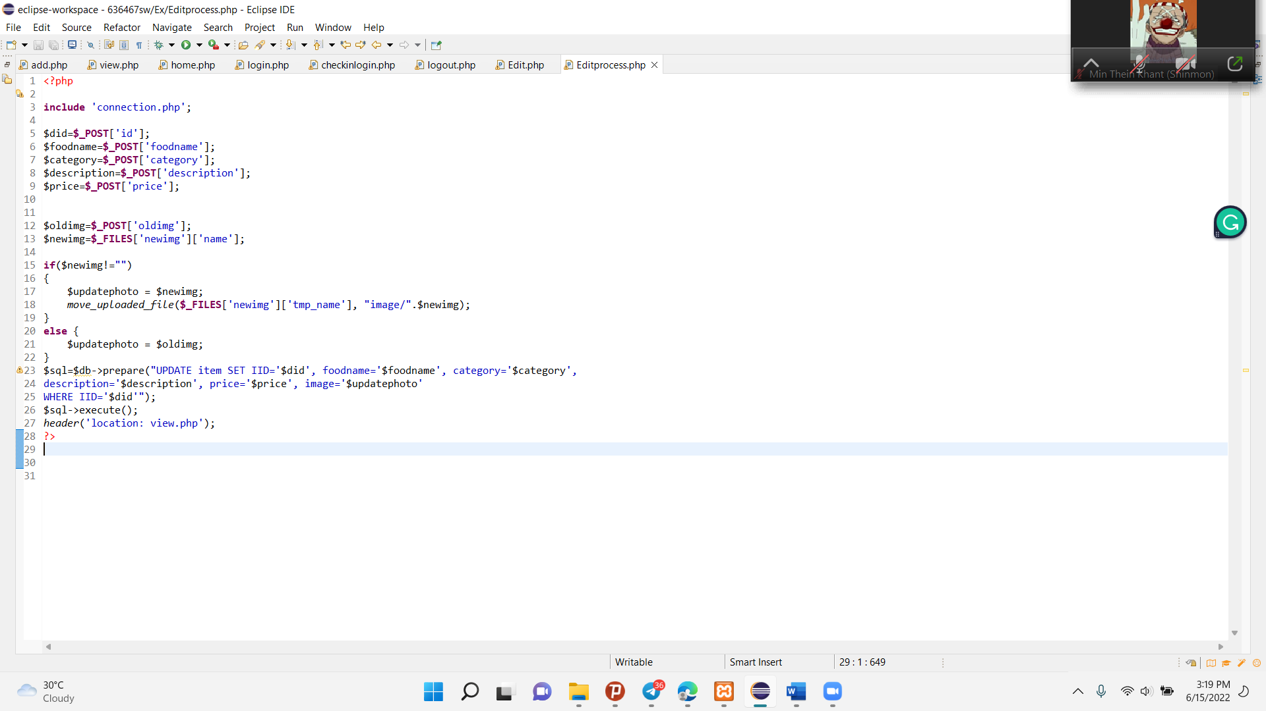

Fig (4.5) PHP code of the Edit process

This code is the main process of edit. Using the Update function , Update that you clicked the item of the data and change the data information in the Item of the database .

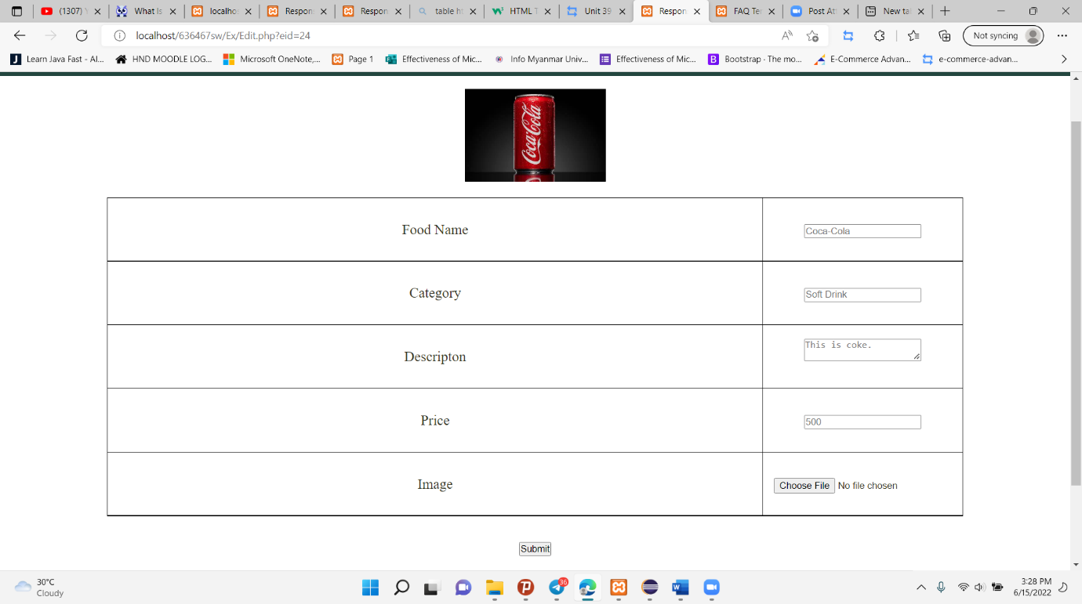

Fig (4.6) Edit Item Page

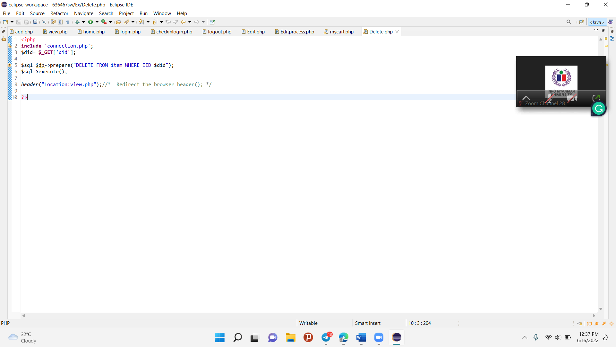

Fig (4.7) PHP code of the Delete function

When you click “Delete” in the view item page, that code will perform. The code call the delete function . That function will perform that you clicked of the item. And the this data will delete in the item database.

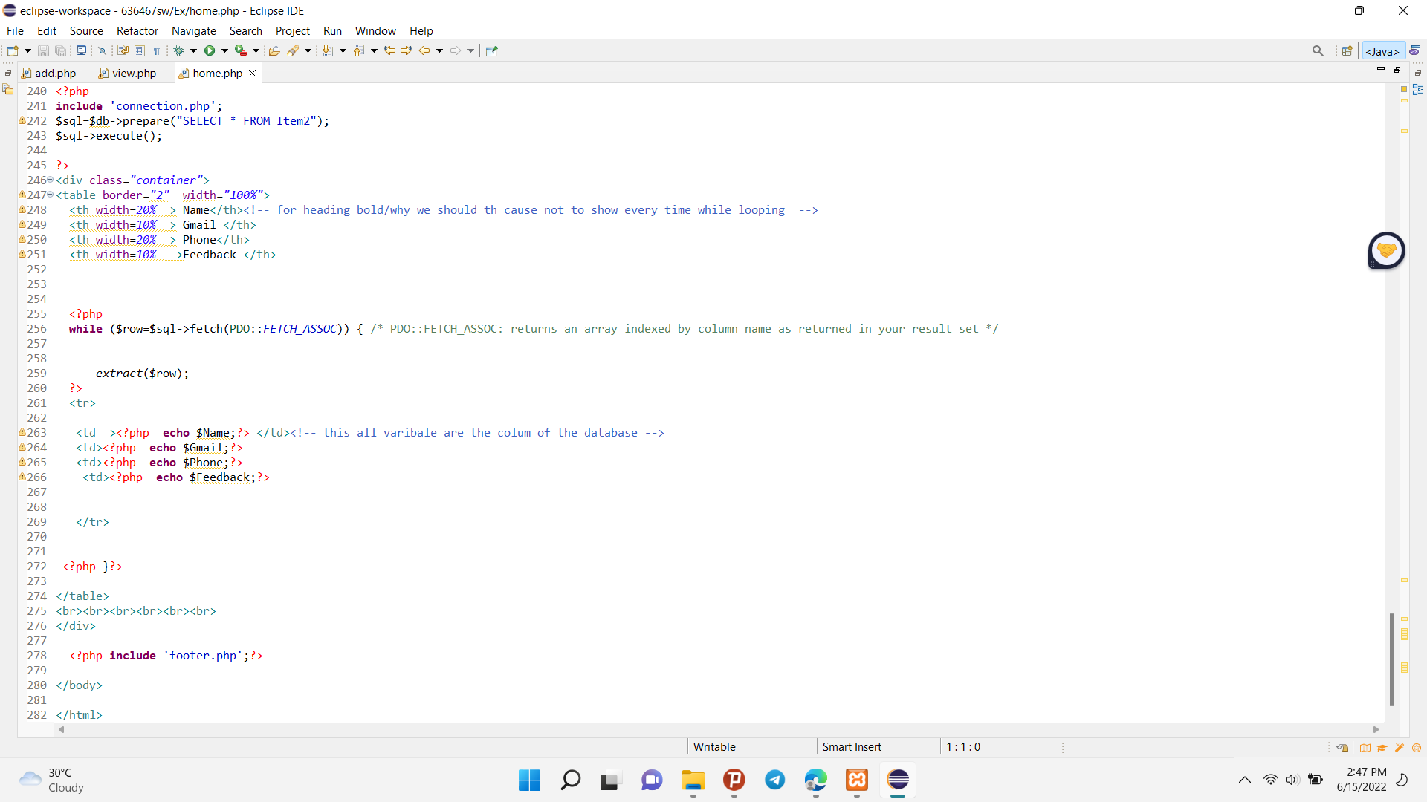

Fig (4.8) PHP code of the Feedback Page

In the client site, customer can give feedback so they fill the contact us form. The data of this form will arrive in the item2 database. The code produced the data by calling the variable of the data from the item2 database.

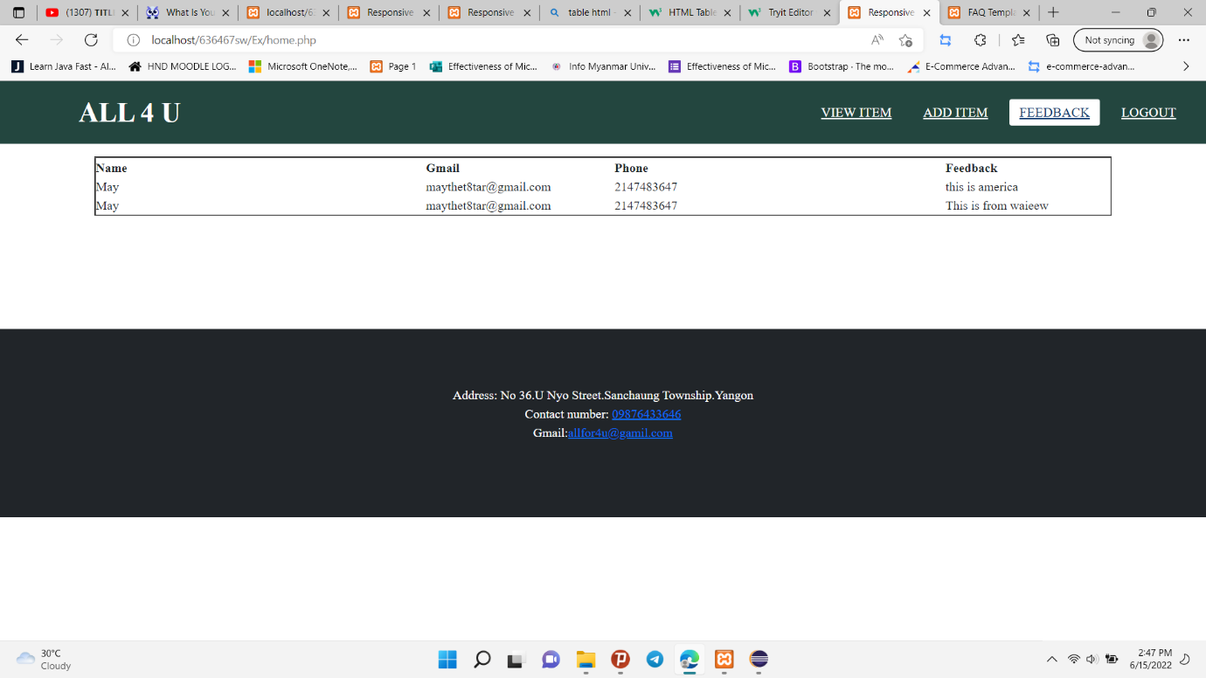

Fig (4.9) Feedback Page

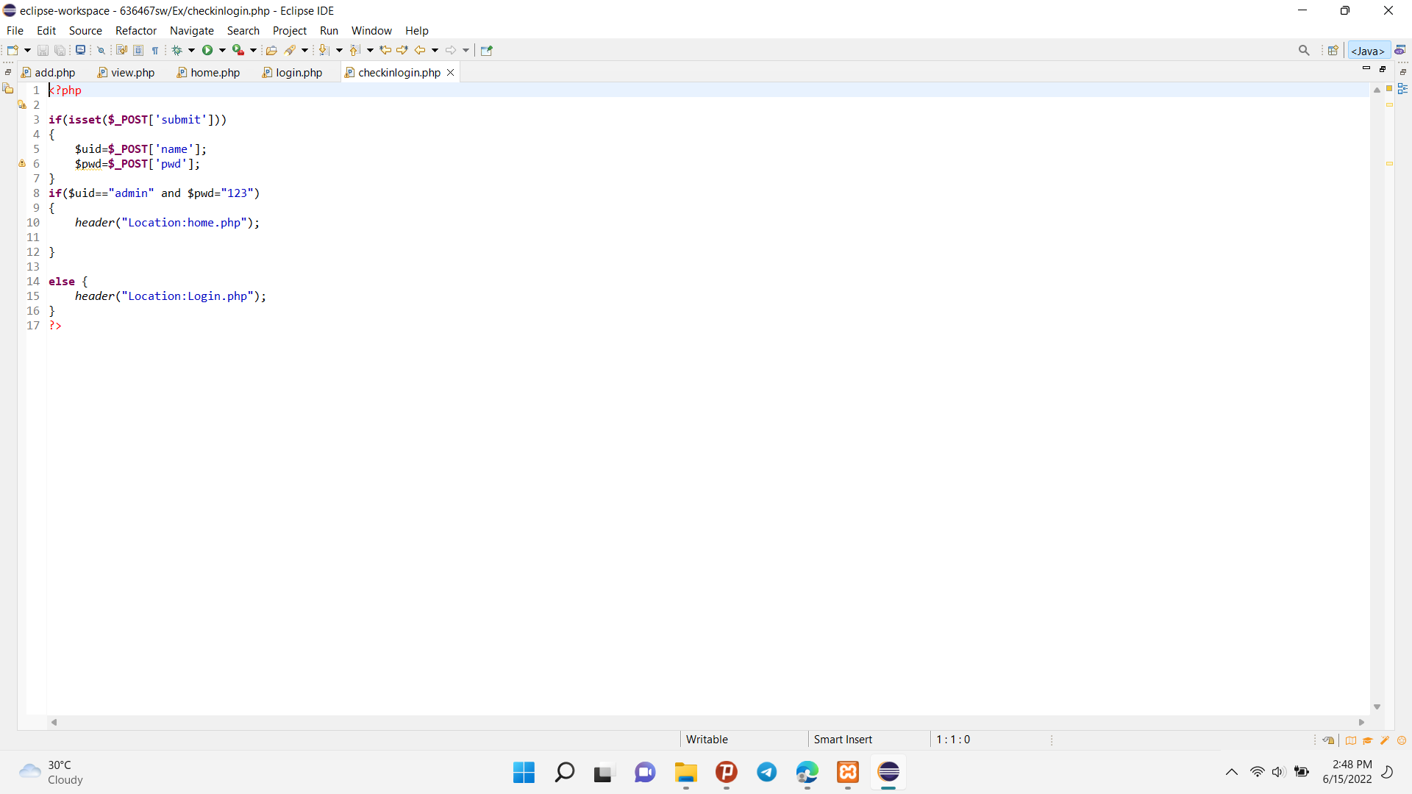

Fig (4.10) PHP code of the Login Page

This check in code is for Admin login page. To be secure for the admin site, if you put the correct username and password, you will arrive the pages of admin site.

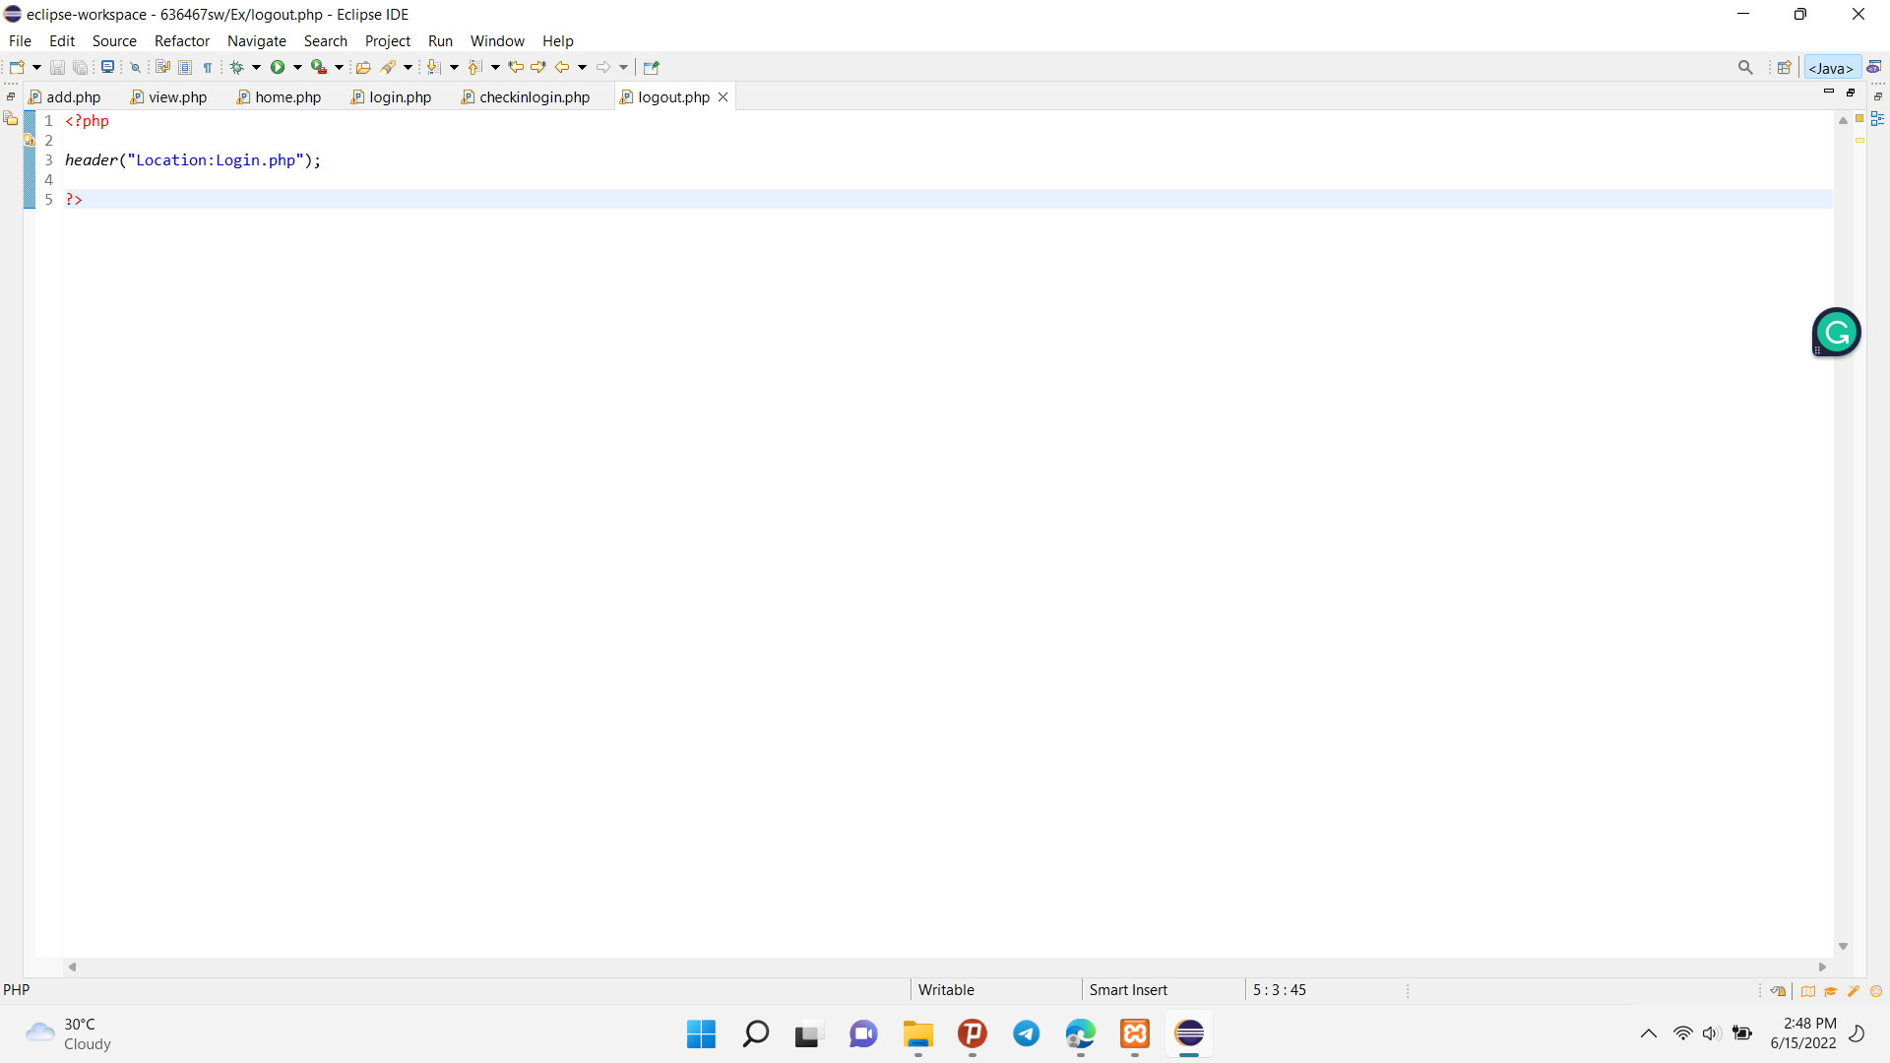

Fig(4.11) PHP code of the Logout Page

This is the logout code. To be easy logout , when you click the logout pattern, you will arrive the login page.

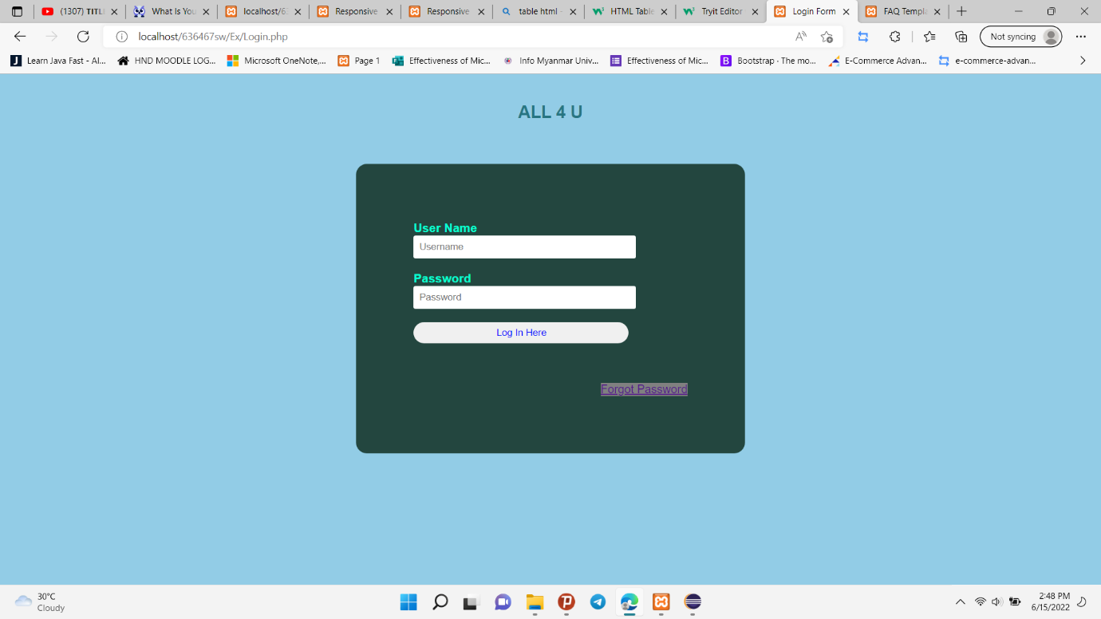

Fig (4.12) Login Page

## Client Site

For the Client site, I have to develop a Home page, All product page, the About us page, the Contact us page, the FAQ page, My Cart page and each item’s description on the View page.

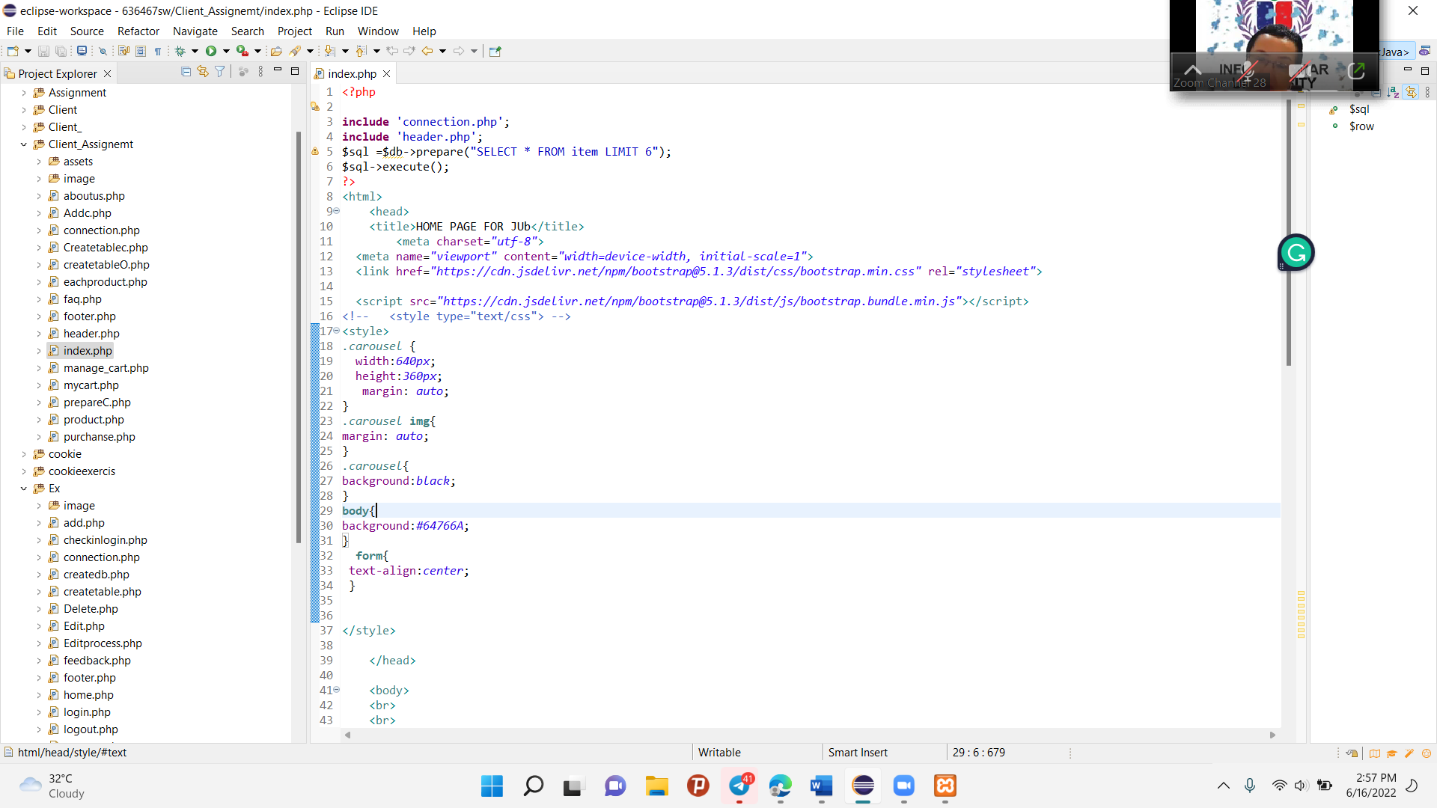

Fig(4.13) PHP code of the Home Page for Client Site

This first php code “include ‘connection.php’ and ‘header.php’” that is calling these file to affect in this page. That connection file is connected with item database. In this home page, I just want to show a little item so when I select 6 items to show on home page from the item database.

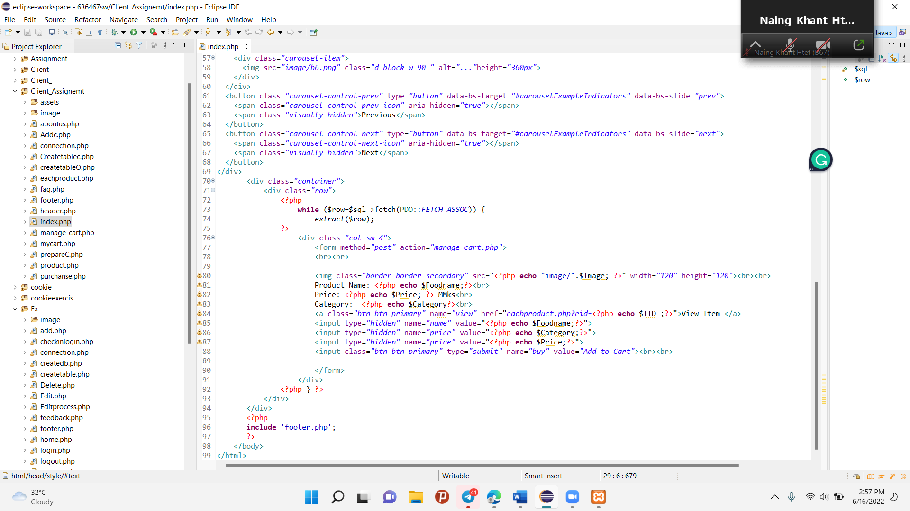

Fig(4.14) PHP code of the Home Page for Client Site

This second PHP code is to show the detail of items by calling every variable of the item. That will be shown on the HTML frame. And then calling the footer.php file to affect on this page.

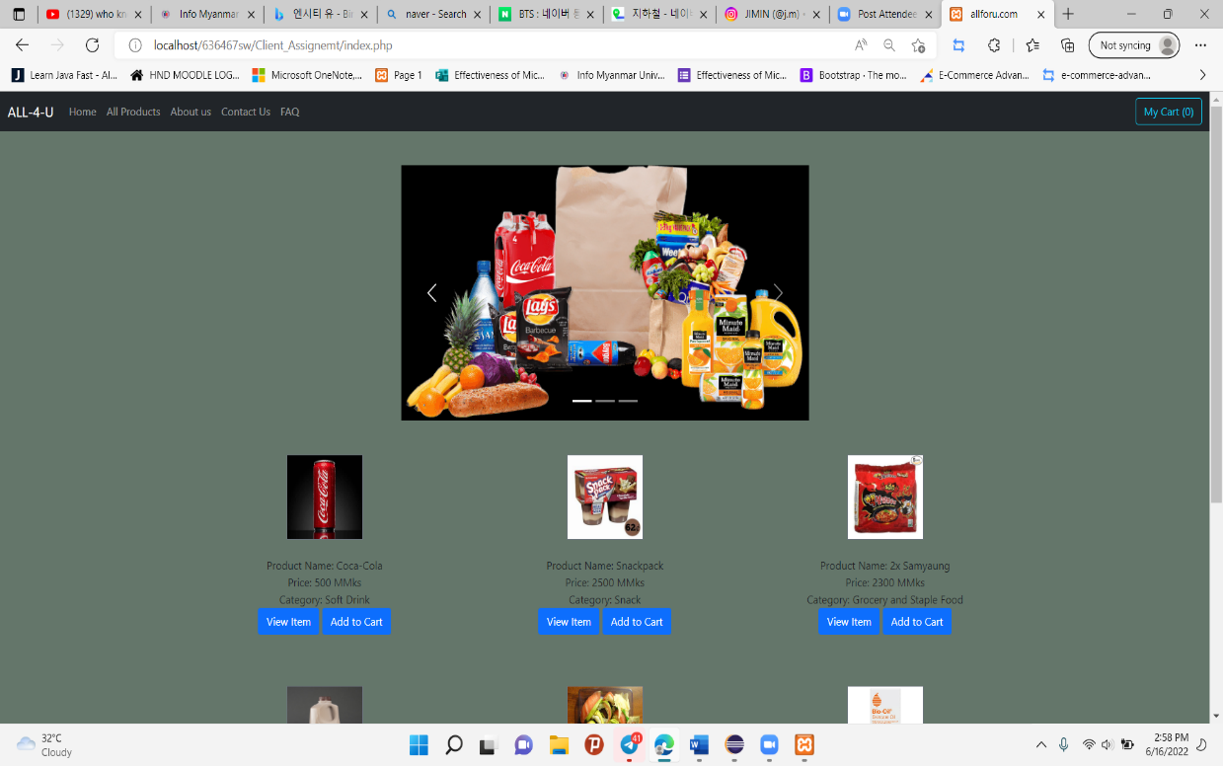

Fig(415.) Homep Page of the Client Site

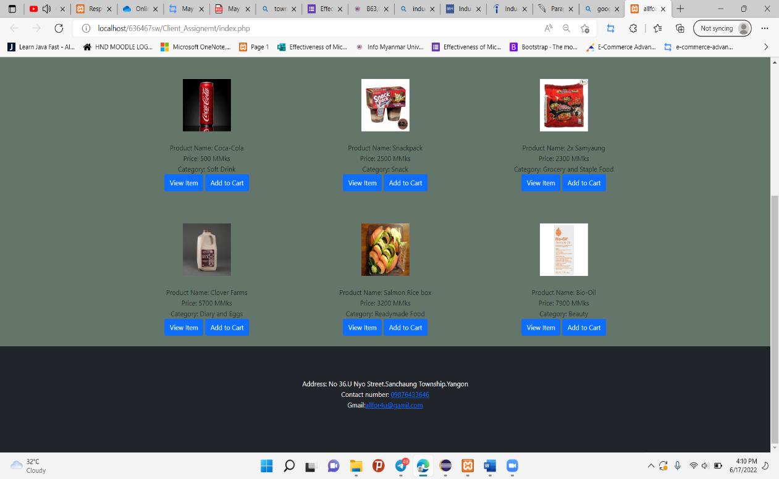

Fig(4.16) Home page of the Client Site

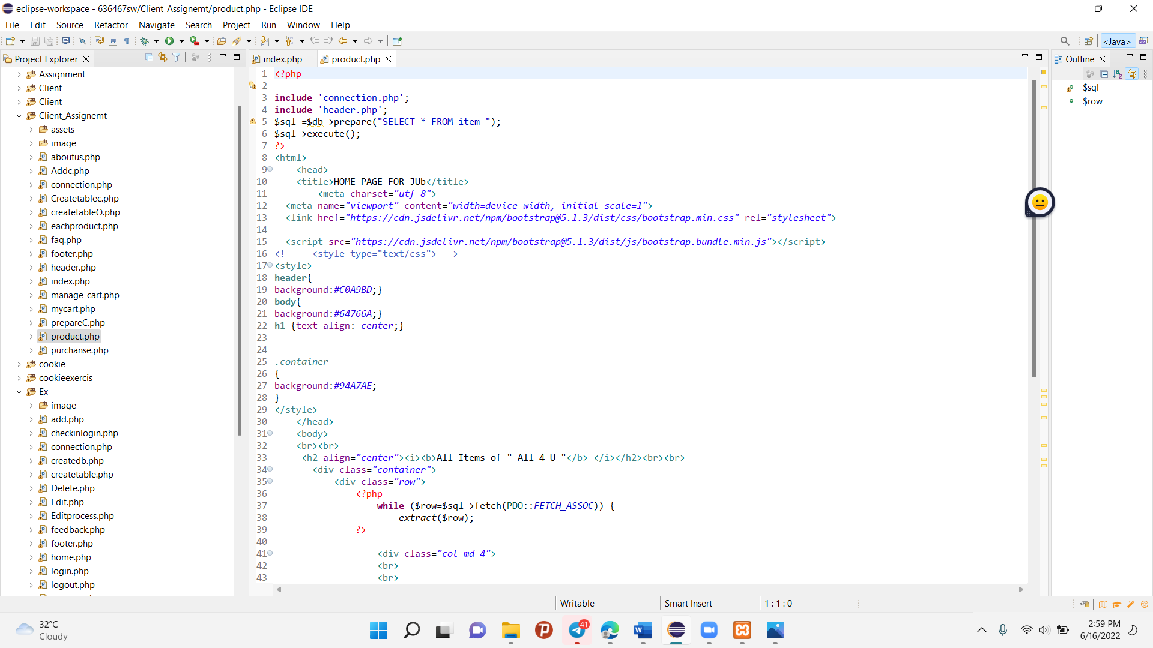

Fig(4.17) PHP code of the All Product Page for Client Site

This first PHP code “include ‘connection.php’ and ‘header.php’” is calling these files to affect this page. That connection file is connected with the item database. In this All product page, I just want to show all items so when I select items to show on the All product page from the item database.

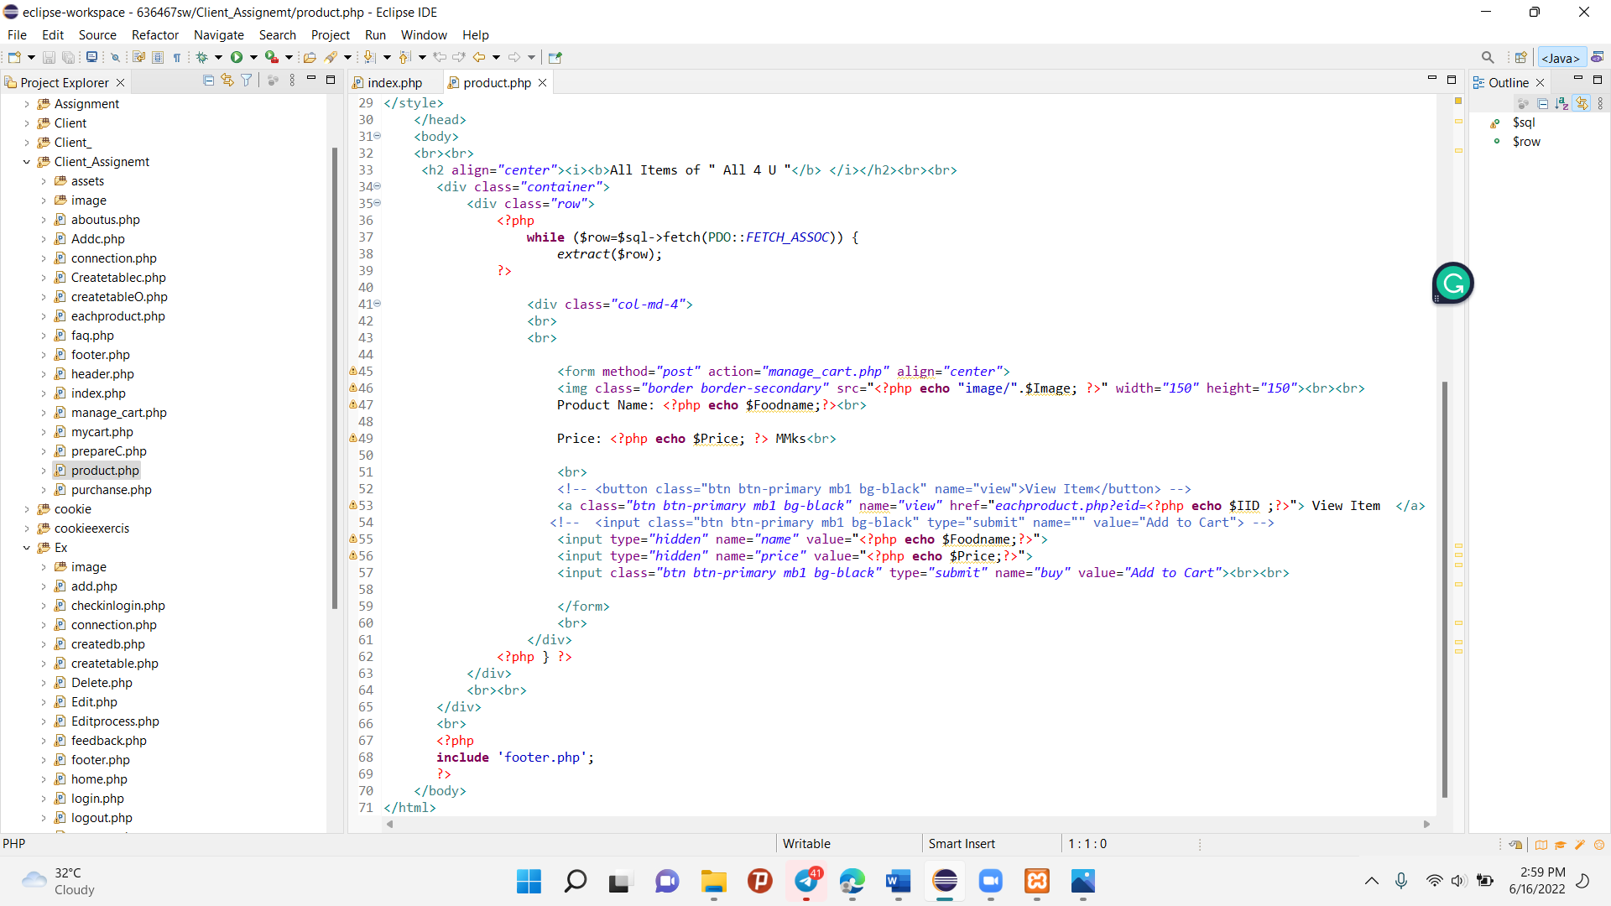

Fig(4.18) PHP code of the All Product Page for Client Site

This second PHP code is to show the detail of items by calling every variable of the item. That will be shown on the HTML frame. And then calling the footer.php file to affect on this page.

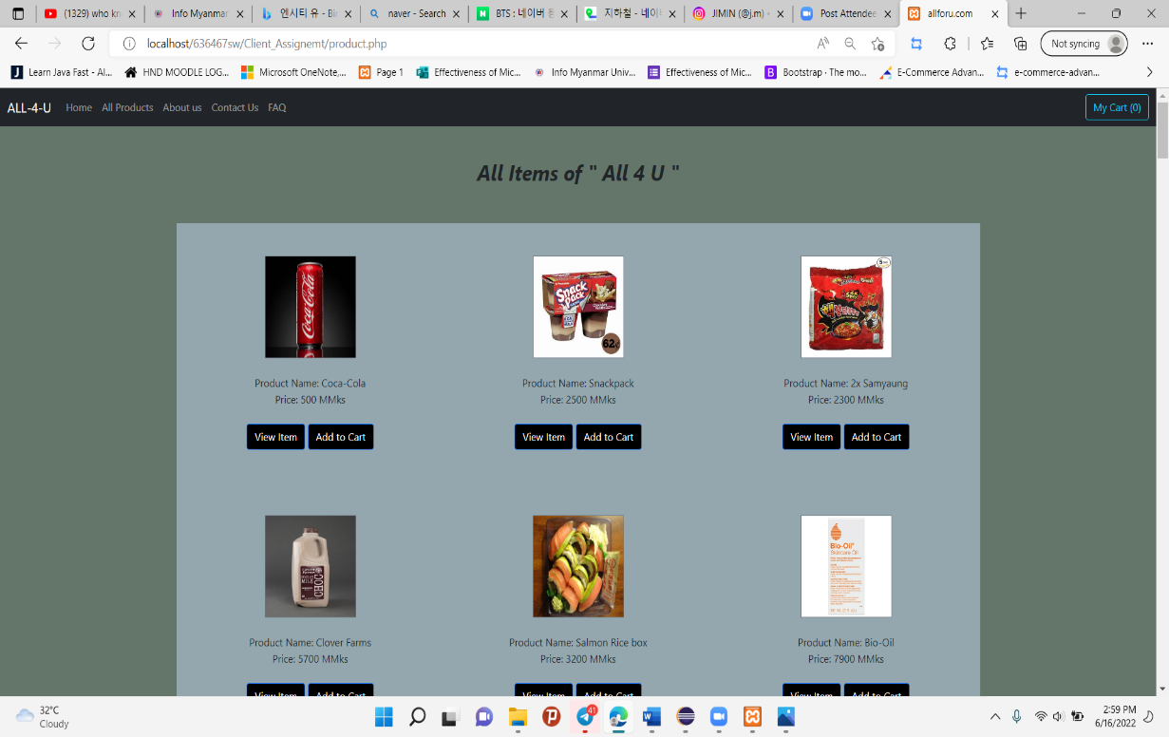

Fig(4.19) All product page of the client site

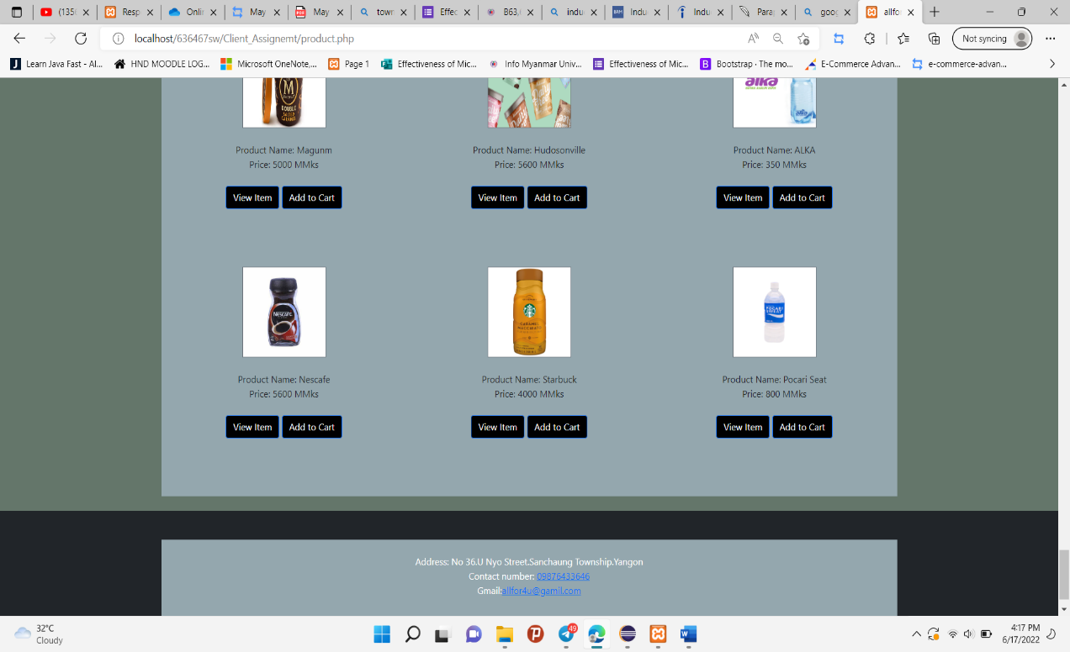

Fig(4.20) All product page of the client site

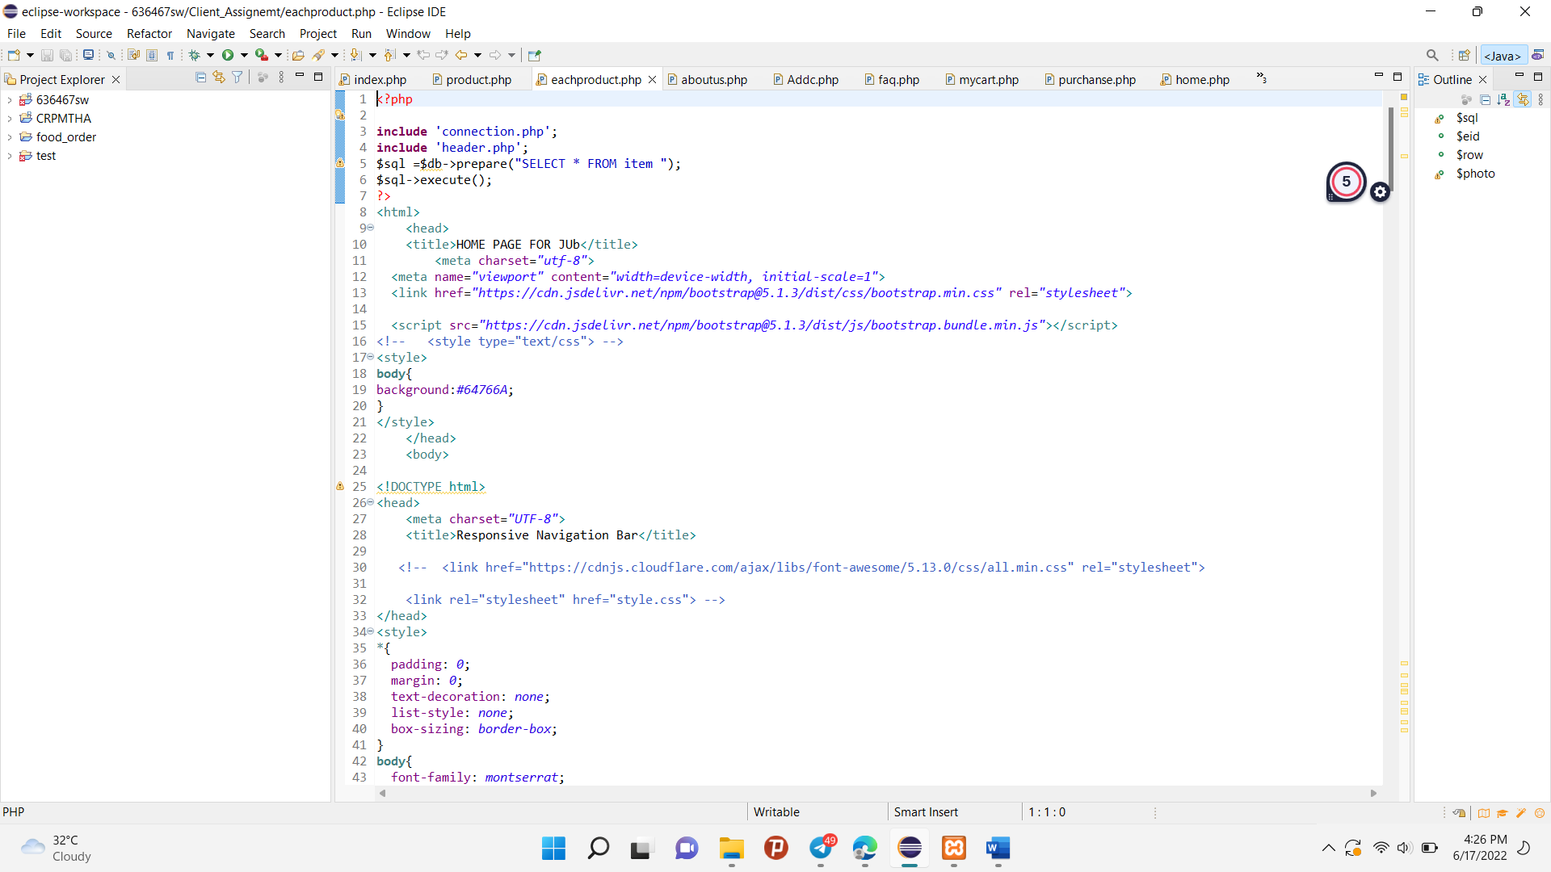

Fig(4.21) PHP code of the View Item Page for Client Site

This first PHP code “include ‘connection.php’ and ‘header.php’” is calling these files to affect this page. That connection file is connected with the item database.

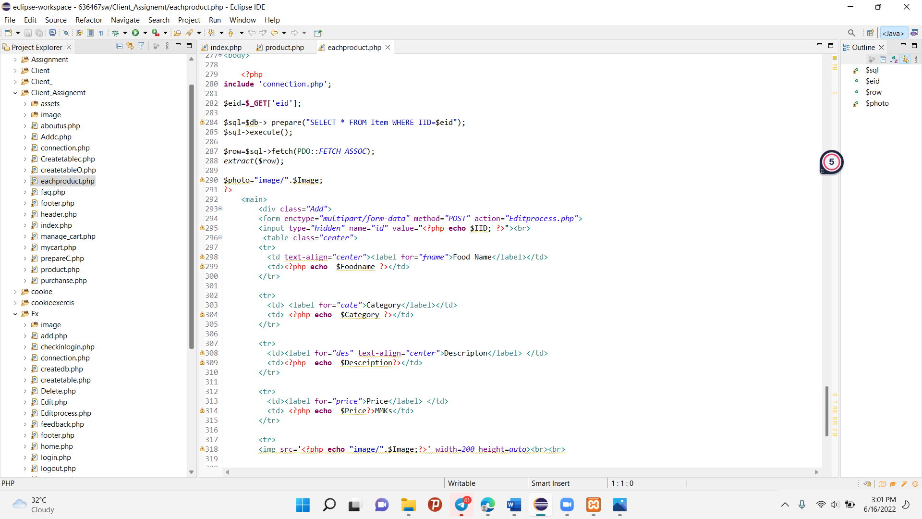

Fig(4.22) PHP code of the View Item Page for Client Site

This coding is connected with the view item button of all product pages and home pages. When you click that button, this coding will perform. That code is just like the edit code in the admin site except submit button.

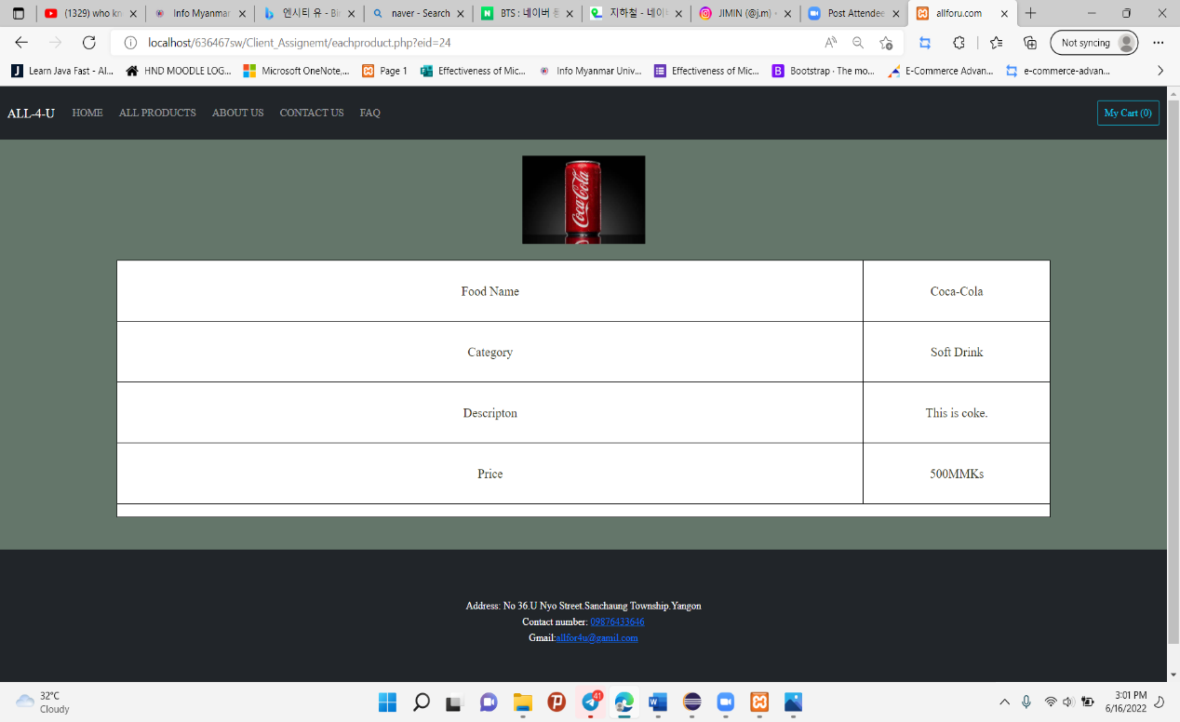

Fig(4.23) View Item page of the client site

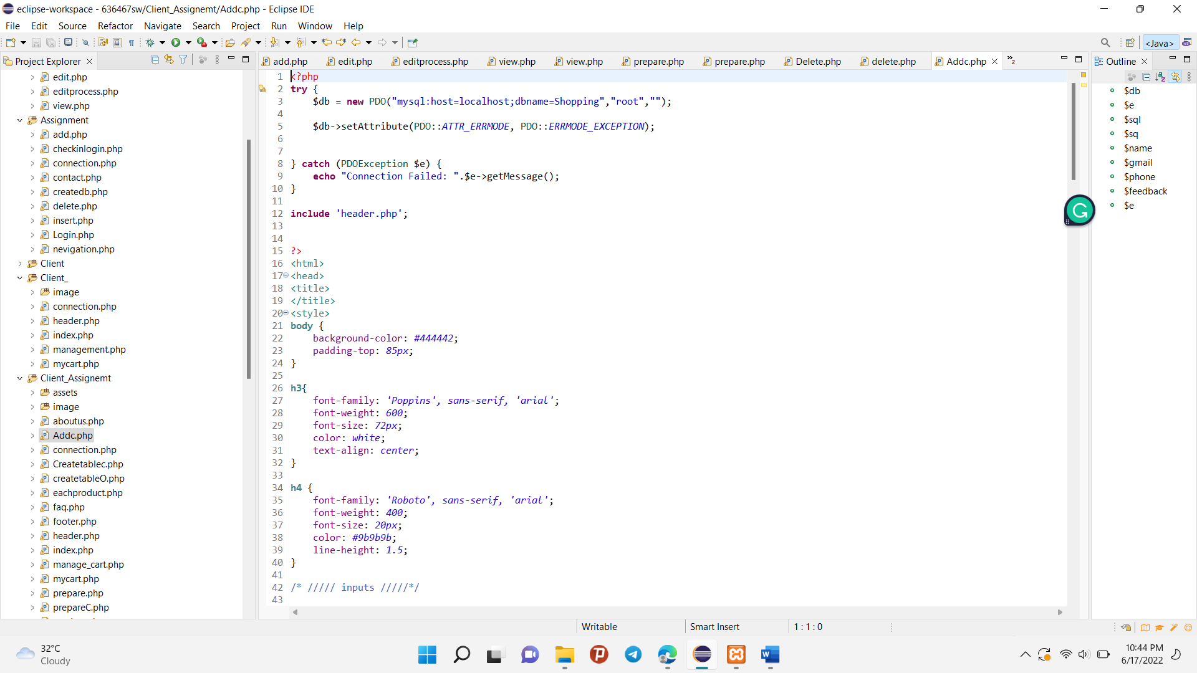

Fig(4.24) PHP code of the Contact Us Page for Client Site

This first PHP code “include ‘connection.php’ and ‘header.php’” is calling these files to affect this page. That connection file is connected with the item database.

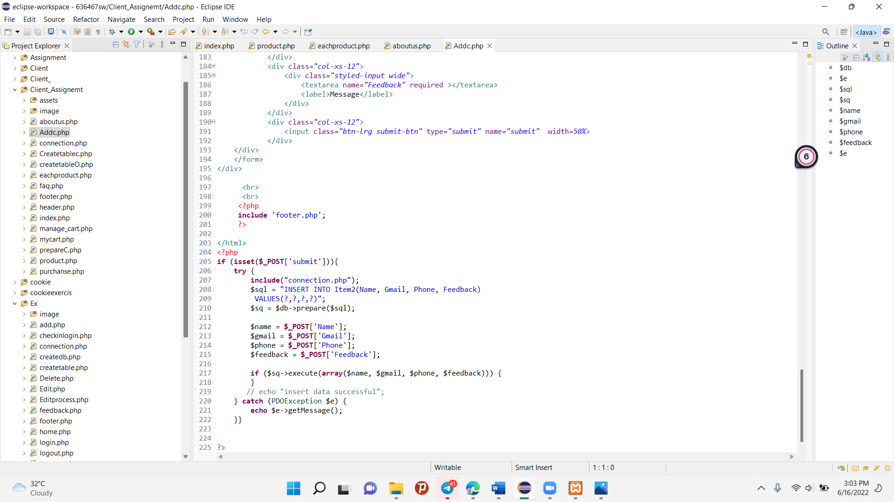

Fig(4.25) PHP code of the Contact Us Page for Client Site

The PHP coding is to give a feedback to admin when client want to inform something by using their name, email, phone number and Messages. So, this coding is to insert the information data to the item2 database when client fill the correct data type. If it was not , this coding show where error happen.

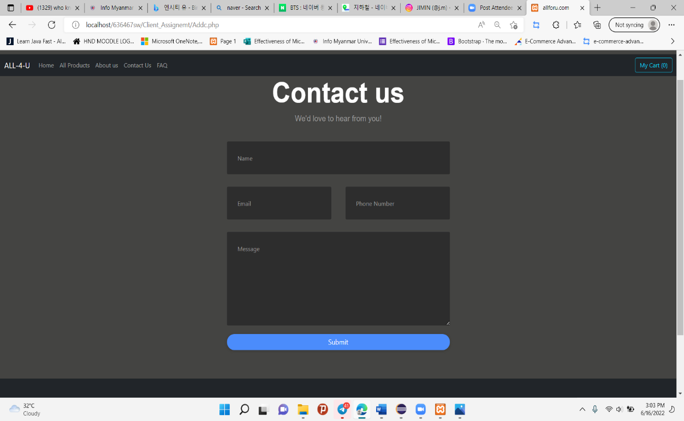

Fig(4.26) Contact Us page of the client site

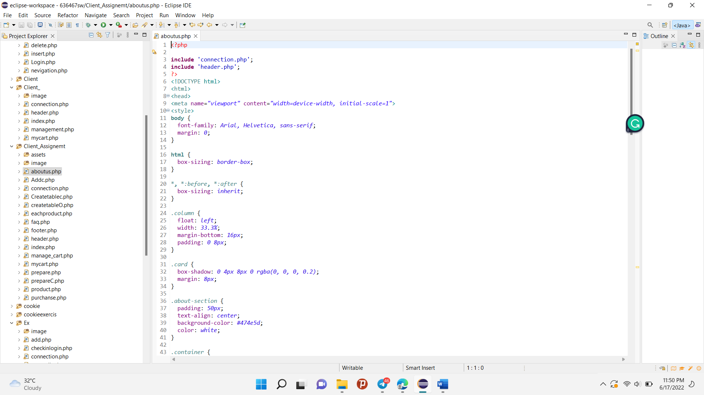

Fig(4.27) PHP code of the About Us Page for Client Site

This PHP code “include ‘connection.php’ and ‘header.php’” is calling these files to affect this page. That connection file is connected with the item database. On this page, I used the HTML frame and CSS frame because there was permanent information about the company and the company’s builders.

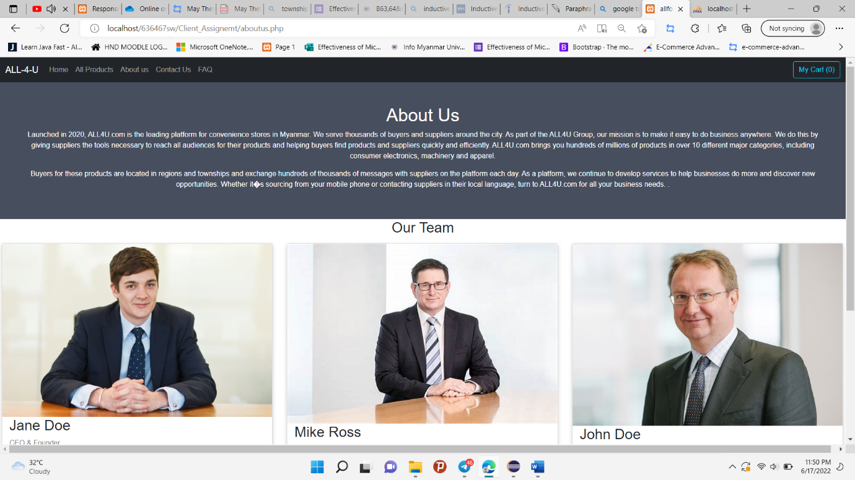

Fig(4.28) About Us page of the client site

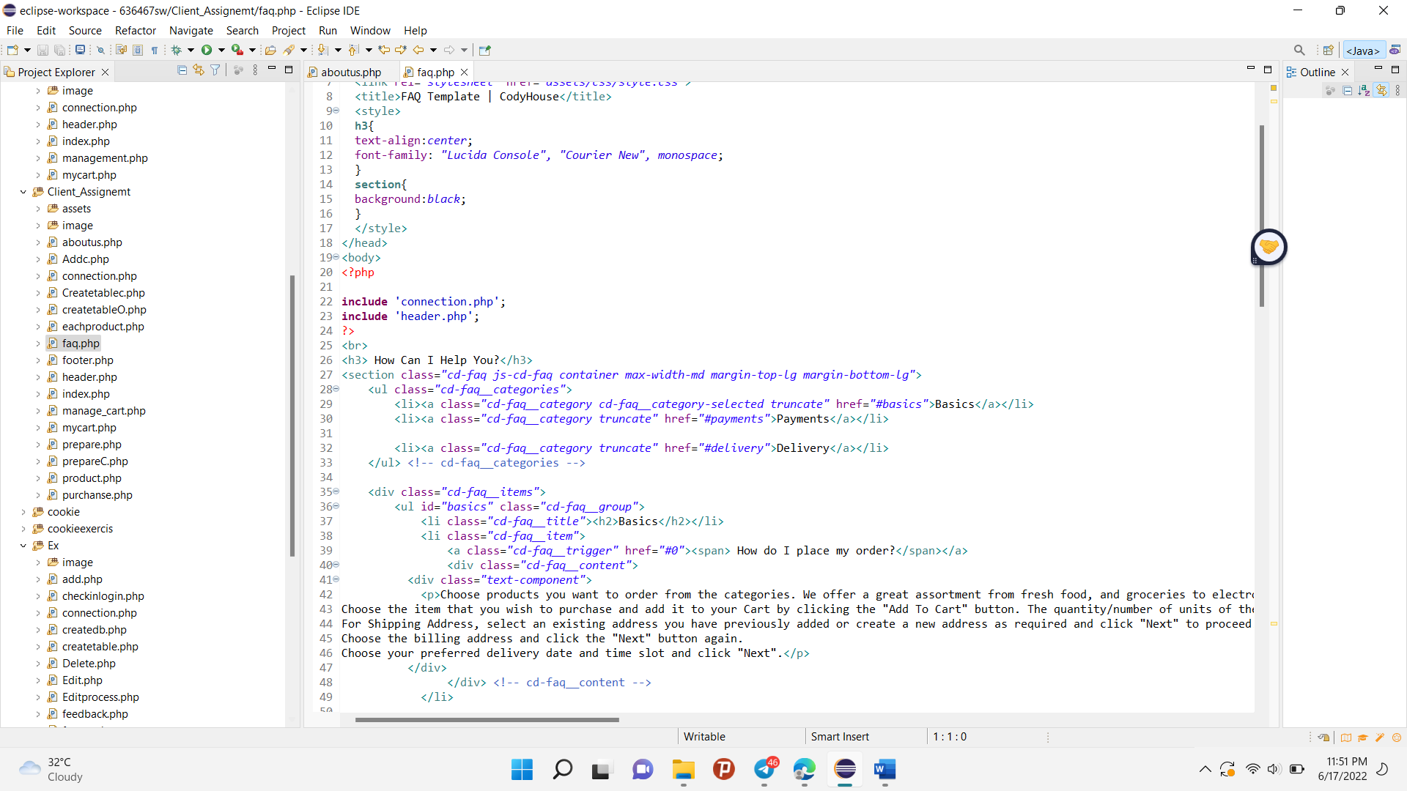

Fig(4.29) PHP code of FAQ Page for Client Site

This PHP code “include ‘connection.php’ and ‘header.php’” is calling these files to affect this page. That connection file is connected with the item database. On this page, I used the HTML frame and CSS frame because there were Frequently Ask Questions and their Answers.

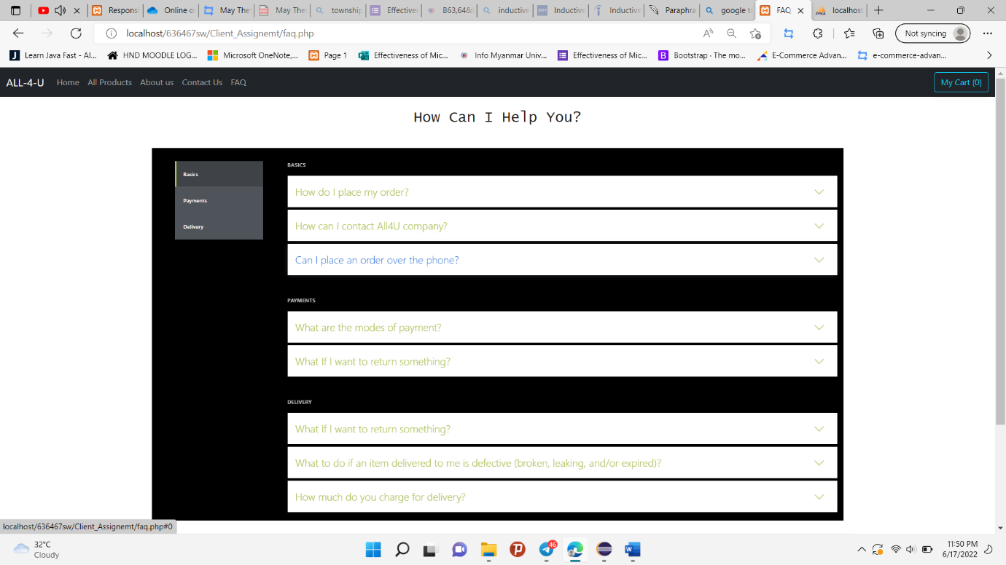

Fig(4.30) FAQ page of the client site

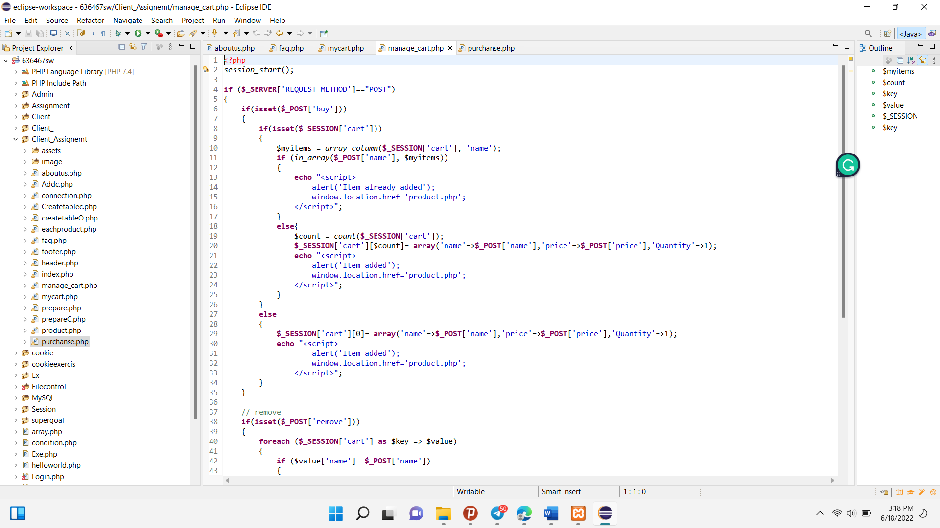

Fig(4.31) PHP code of the My Cart Page for Client Site

The First PHP code is connected with the “Add to cart ”button on the Home and All product. When you click the button of item, that code will perform. That code is to insert the order manage database that you clicked the item. So that browser show “Item added”. Furthermore, if the item already exists in the order manage database, the browser show “Item already added”. And then you will arrive “All Product” Page.

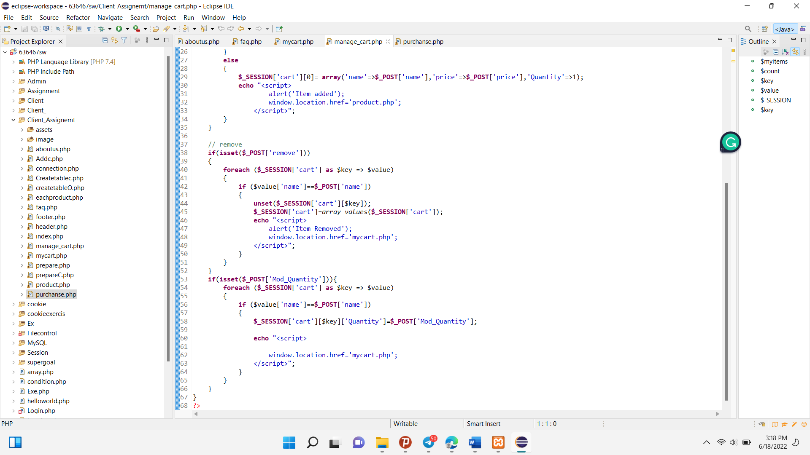

Fig(4.32) PHP code of the My Cart Page for Client Site

The code is for the My cart Page. In this “My Cart” Page, that item order which client chose. Beside of these item have Remove that client remove their items to be easily. And then the next “Mod_Quantity” code is to reduce and increase the amount of item quantity.

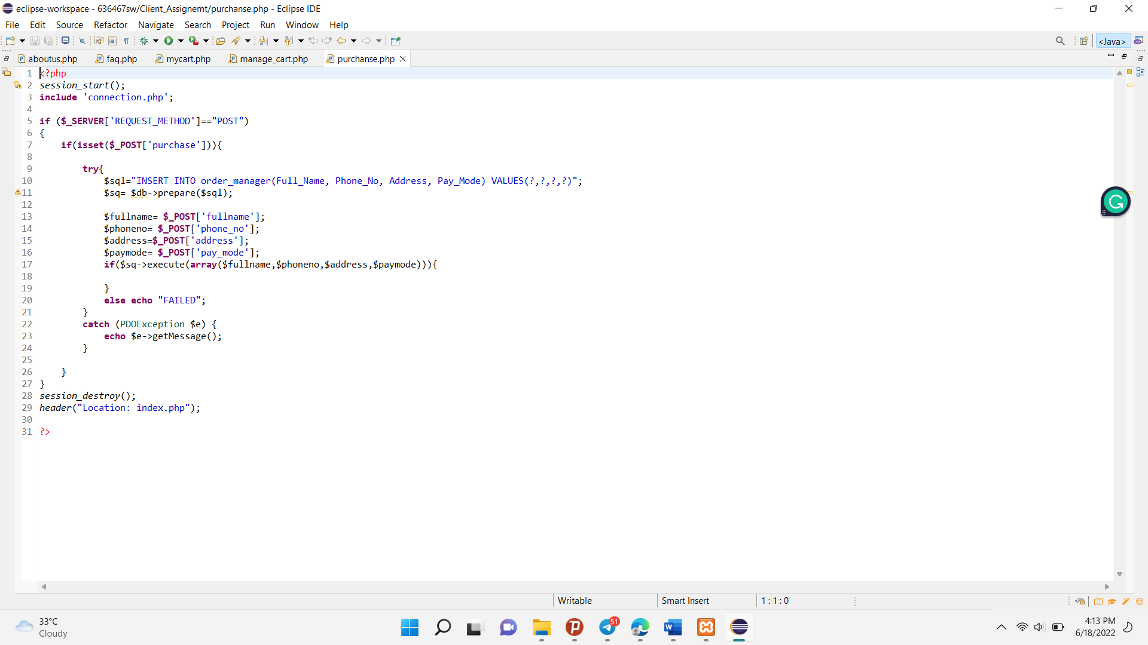

Fig(4.33) PHP code of the My Cart Page for Client Site

That PHP code is to insert the data of the client in my cart form to the order manage database. If client put the data correctly that will be successfully arrived to the database. Otherwise, the process will fail and show the error what is wrong.

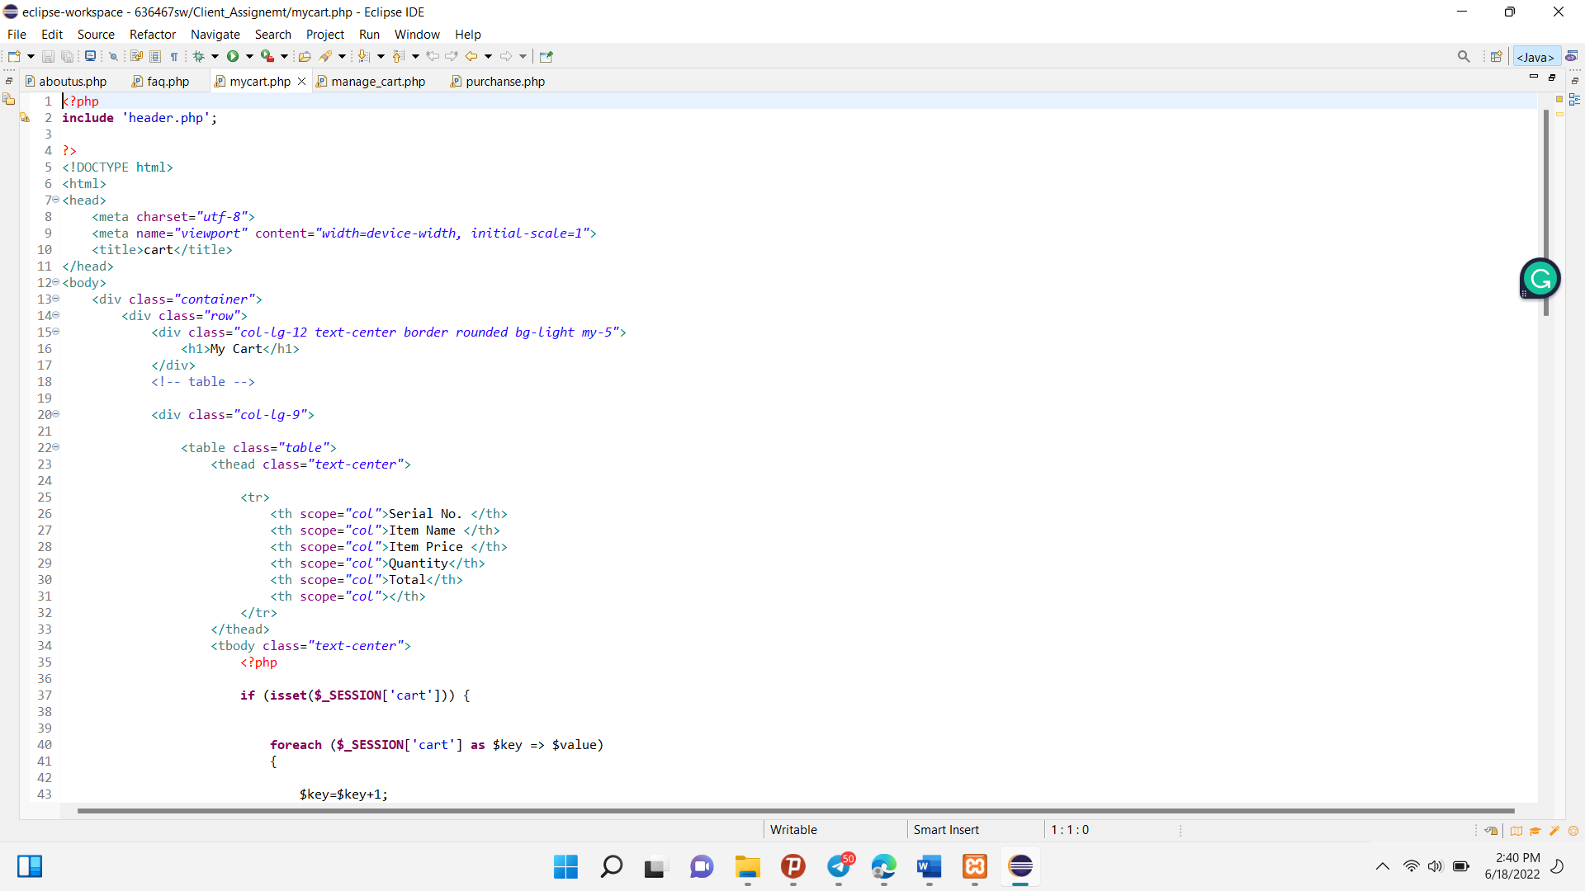

Fig(4.34) PHP code of the My Cart Page for Client Site

The First PHP code is calling header.php by using include PHP method. That will show the header division on this my cart page.

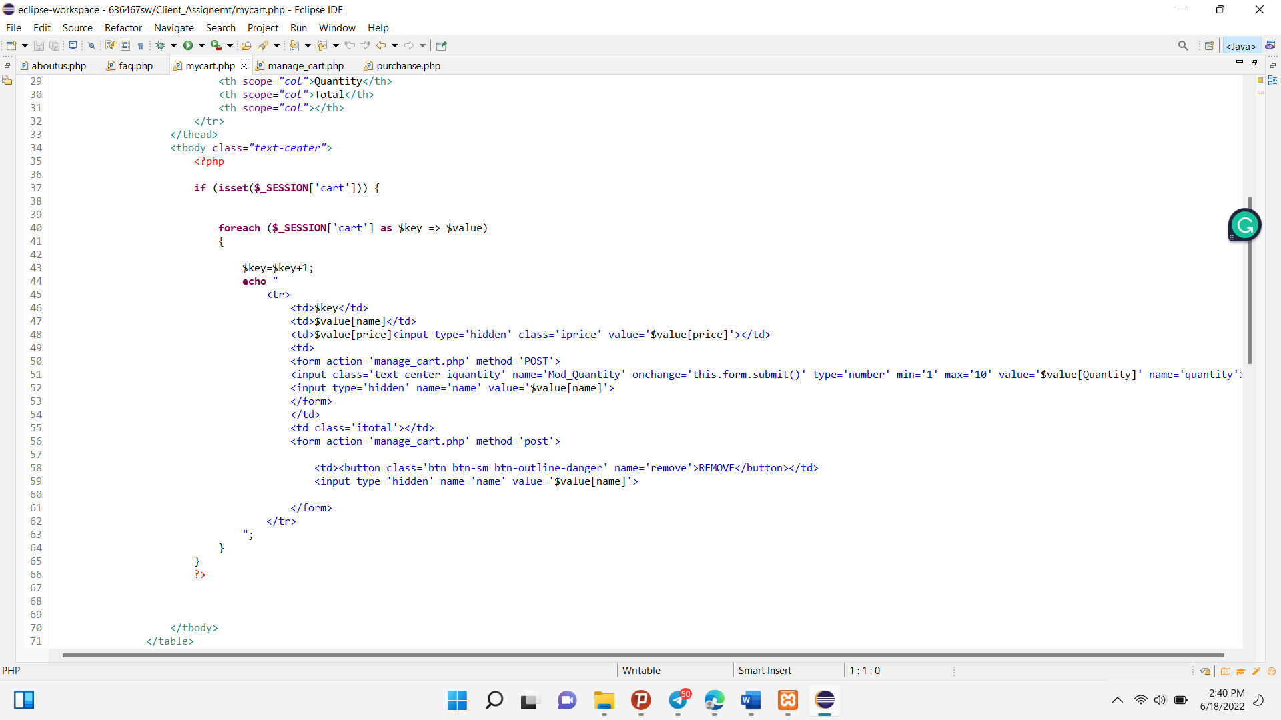

Fig(4.35) PHP code of the My Cart Page for Client Site

This code is the calculation of the total price. That was the multiplication of the item original price and quantity of item. And then that will calculate the total price that all addition of items that client ordered.

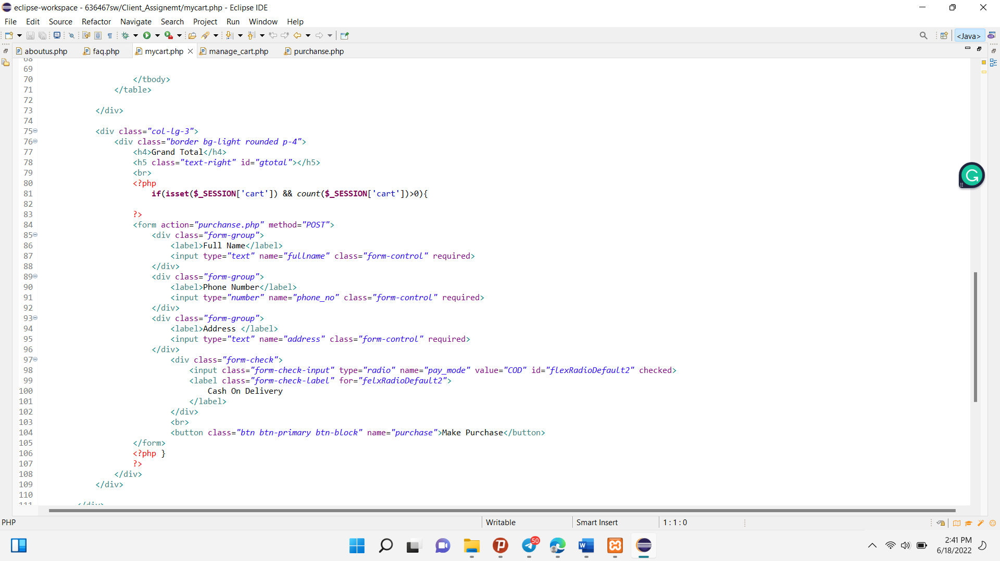

Fig(4.36) PHP code of the My Cart Page for Client Site

The coding is the form to add the client information to the order manage database. By using the HTML and CSS frame, that show the client need to fill the requirement data for the Order manage database.

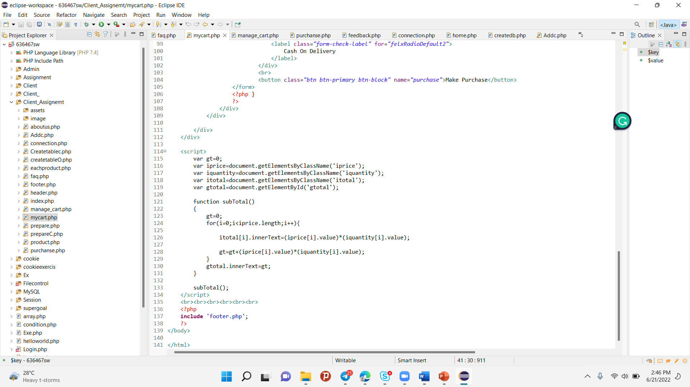

Fig(4.37) PHP code of the My Cart Page for Client Site

This java script code is for check out. The check out means to calculate the total price of the item and item’s quantity.

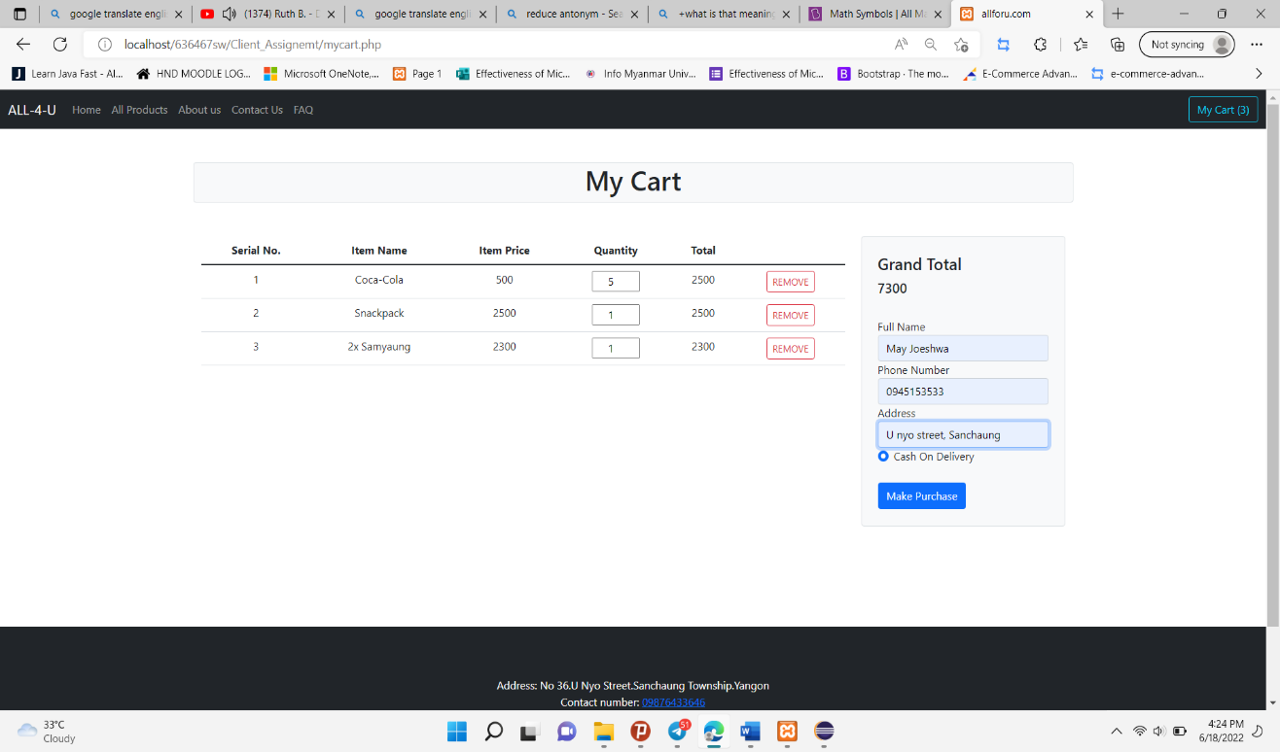

Fig(4.38) My Cart page of the client site

## Reference

SHERIDAN [Online] Available From:

http://www.sheridancomputers.co.uk/computer-maintenance

[Accessed: 15.3.19]

EHORUS [Online] Available From:

https://ehorus.com/computer-maintenance/

[Accessed: 15.3.19]

Puget Systems [Online] Available From:

https://www.pugetsystems.com/labs/articles/Top-10-things-you-should-be-doing-to-maintain-your-computer-39/

[Accessed: 15.3.19]

Money Crashers [Online] Available From:

https://www.moneycrashers.com/computer-maintenance-tips-checklist/

[Accessed: 15.3.19]